Assignment

[Student Name]
[University Name]
[Course Number and Name]
[Instructor Name]
[Date]

Campus Population Snapshot: Algal Growth in the Pond of Southern University A&M College.
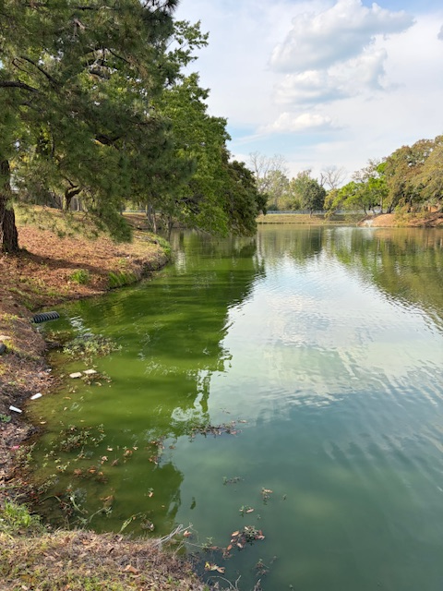
The existing pond near the Mayberry Cafeteria at Southern University A&M College offers a good illustration of how biological populations can develop and be controlled in a campus setting. In this observation, one is concerned with the seen algae population on sections of the water surface. Algae may not be the biggest subject matter of study; however, it is an essential part of aquatic life and provides an excellent example of population growth and interaction with the environment.
Based on direct observations of the pond, the algae population is quite high in areas near the shoreline, where the water appears distinctly green. Conversely, the intermediate regions of the pond are of moderate density, and deep or open water regions have lower concentrations. This implies that the algae are not uniformly distributed, but rather are clumped. This trend is probably because the nutrients and organic materials are deposited in the pond more in the edges and therefore, in these parts of the pond, algae thrive better.
The presence of algae in this environment depends on several biological and environmental factors, which contribute to its growth. Algae populations have been found to grow very fast when the conditions, such as sunlight availability, warm temperatures, and nutrient availability, are favorable. Such conditions facilitate photosynthesis, whereby the algae reproduce fast and multiply in number. This form of rapid growth is a manifestation of the population growth concept, where organisms proliferate in good conditions. But this increase is not indefinite, and there are some limiting factors that regulate this increase.
The algae population in the pond is controlled by a number of factors. Among these is the presence of nutrients like nitrogen and phosphorus, which can be introduced into the water either through run-offs or natural channels. Also, the population size may depend on oxygen content in the water, as algae may grow too much, making the remaining organisms have low oxygen levels. Space and competition with other species present in the water also contribute to the reduction of population growth. These conditions can also be influenced by human activity, such as pollution or landscaping methods on the campus, which can lead to variations in population over time.
The availability of nutrients and the environment may modify the population trends on campus, which might vary because of a rise in pollution levels or weather changes. This underscores the fact that changes in the environment in small amounts can cause important effects on the biological system.
This case illustrates how the biological concepts relate quite closely to the campus life at Southern University A&M College. The pond is not just a visual element of the campus, but it is also a living ecosystem, which is influenced by nature and human activities. The population of the algae will help to demonstrate that biology is not simply a textbook and laboratory place, but it is present in the environment.
Being the opening project in this semester-long portfolio, the current project provides a base of knowledge on the processes of population growth and regulation in the real-life context. Further entries will expand this knowledge by investigating more complicated biological systems and how these processes relate to human health and the community at large.

