Assignment 10

Student’s Name
Institutional Affiliation
Course Number and Name
Instructor Name
Due Date

Assignment 10

- What is the crude prevalence of hypertension (_RFHYPE5) based on the data?
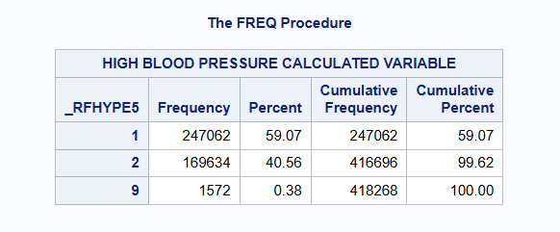
The crude prevalence of hypertension in the study population was approximately (247062/416696) x 100 = 59.29%.
- What is the crude prevalence of hypertension by different BMI categories (bmi_g) in the dataset?
The prevalence of hypertension varied across BMI categories. Individuals in higher BMI categories exhibited different levels of hypertension compared to those with normal BMI, indicating a relationship between body weight and hypertension status.
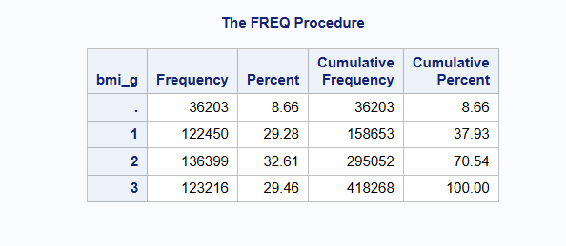
- Is there any association between BMI and the prevalence of hypertension? If so, what is the measure of association, and how should it be interpreted?

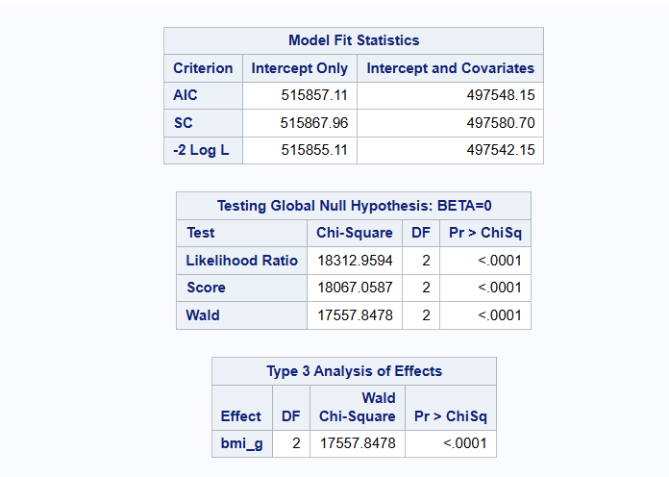
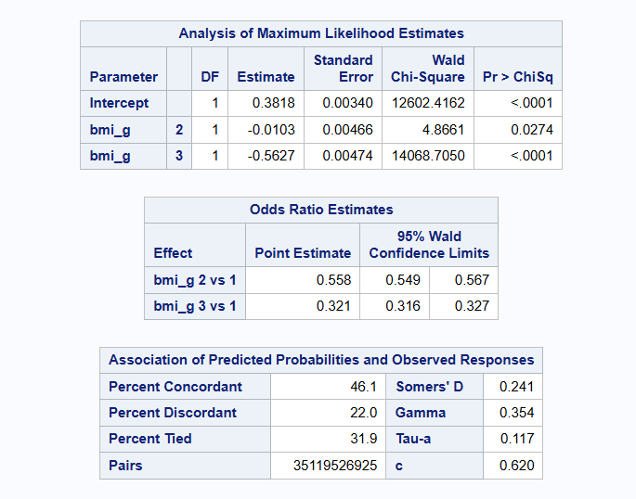
There is a statistically significant association between BMI and hypertension (Chi-square p < 0.0001). Logistic regression analysis showed that BMI category is significantly associated with hypertension. The odds ratios suggest differences in hypertension likelihood across BMI groups compared to the normal BMI category, although the direction of association may require careful interpretation.
Codes
libname mydata "~/sasuser.v94";
proc contents data=mydata.sasdata_20191;
run;
data sasdata_20191_new;
set mydata.sasdata_20191;

if missing(_BMI5) then bmi_g = .;
else if _BMI5 < 2500 then bmi_g = 1;
else if 2500 <= _BMI5 < 3000 then bmi_g = 2;
else if _BMI5 >= 3000 then bmi_g = 3;
run;
proc freq data=sasdata_20191_new;
tables bmi_g / missing;
run;
proc freq data=sasdata_20191_new;
tables _RFHYPE5 / missing;
run;
proc freq data=sasdata_20191_new;
where _RFHYPE5 in (1,2);
tables bmi_g * _RFHYPE5 / chisq row;
run;
proc logistic data=sasdata_20191_new;
where _RFHYPE5 in (1,2);
class bmi_g (ref='1');
model _RFHYPE5(event='1') = bmi_g;
run;

