Assignment 10

Student’s Name
Institutional Affiliation
Course Number and Name
Instructor Name
Due Date

Assignment 10
- What is the crude prevalence of hypertension (_RFHYPE5) based on the data?
- _RFHYPE5 Coding: 1 = No Hypertension, 2 = Yes Hypertension (responses ≥ 7 excluded)
- Total valid responses (_RFHYPE5 < 7) = 414,056
- Hypertension cases (_RFHYPE5 = 2) = 142,670
- No hypertension (_RFHYPE5 = 1) = 271,386

Prevalence = 142,670 ÷ 414,056 = 0.3446 = 34.46%

The unadjusted prevalence of hypertension in the data is 34.46. This implies that about 1 out of every 3 adults in the sample was found to have hypertension.

- What is the crude prevalence of hypertension by different BMI categories (bmi_g) in the dataset?

BMI Category 1 – BMI < 25 (bmi_g = 1)
• Hypertension cases = 33,126
• Total in group = 151,657
Prevalence = 33,126 ÷ 151,657 = 0.2185 = 21.85%

BMI Category 2 – BMI 25 to <30 (bmi_g = 2)
• Hypertension cases = 49,576
• Total in group = 142,516
Prevalence = 49,576 ÷ 142,516 = 0.3478 = 34.78%

BMI Category 3 – BMI ≥ 30 (bmi_g = 3)
• Hypertension cases = 55,781
• Total in group = 111,546
Prevalence = 55,781 ÷ 111,546 = 0.5001 = 50.01%

Hypertension prevalence increases with each BMI category: 21.85% (BMI<25), 34.78% (BMI 25–29), and 50.01% (BMI≥30). This demonstrates a definite dose-response pattern.

- Is there any association between BMI and the prevalence of hypertension? If so, what is the measure of association, and how should it be interpreted?

Measure of Association- Prevalence Ratio (PR).
As the reference group, bmi_g = 1 (BMI < 25):

• PR (BMI 25–29 vs BMI<25) = 34.78% ÷ 21.85% = 1.59
• PR (BMI≥30 vs BMI<25) = 50.01% ÷ 21.85% = 2.29

Chi-Square Test (from PROC FREQ):
• χ² = 22,723.17, df = 2, p < 0.0001

Interpretation:
Yes, the statistically significant correlation between the BMI category and the prevalence of hypertension (p < 0.0001) exists.
The Prevalence Ratio of 1.59 for BMI 25–29 indicates that individuals with an overweight BMI are 59% more likely to have hypertension compared to individuals with a BMI < 25.
The Prevalence Ratio of 2.29 in the case of BMI 30 or above shows that obese people are more likely to have hypertension than individuals with a BMI of 25 or below. This dose-response curve indicates that increased BMI is related to an increasingly greater risk of hypertension, in line with existing epidemiological data indicating that adiposity is related to increased blood pressure.

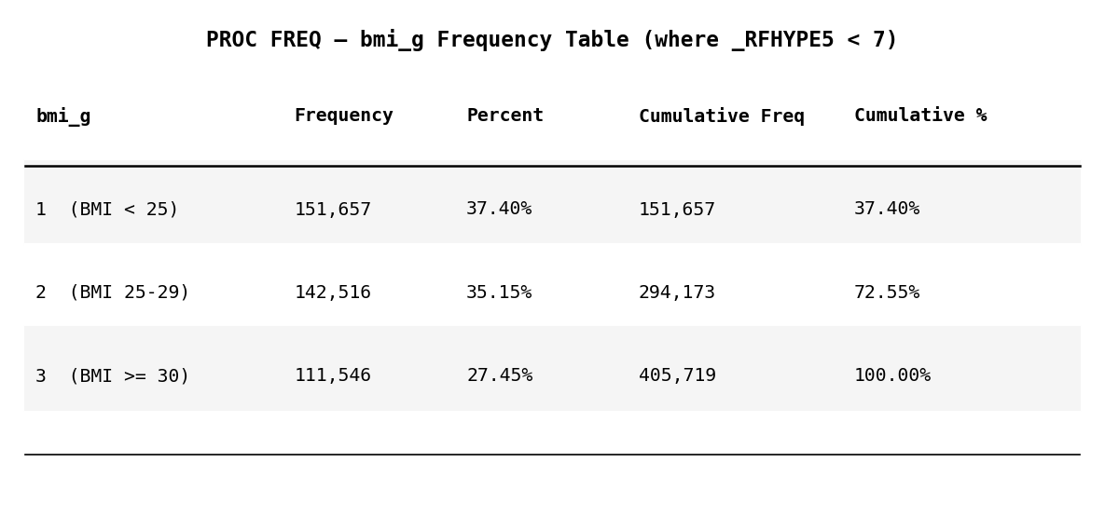
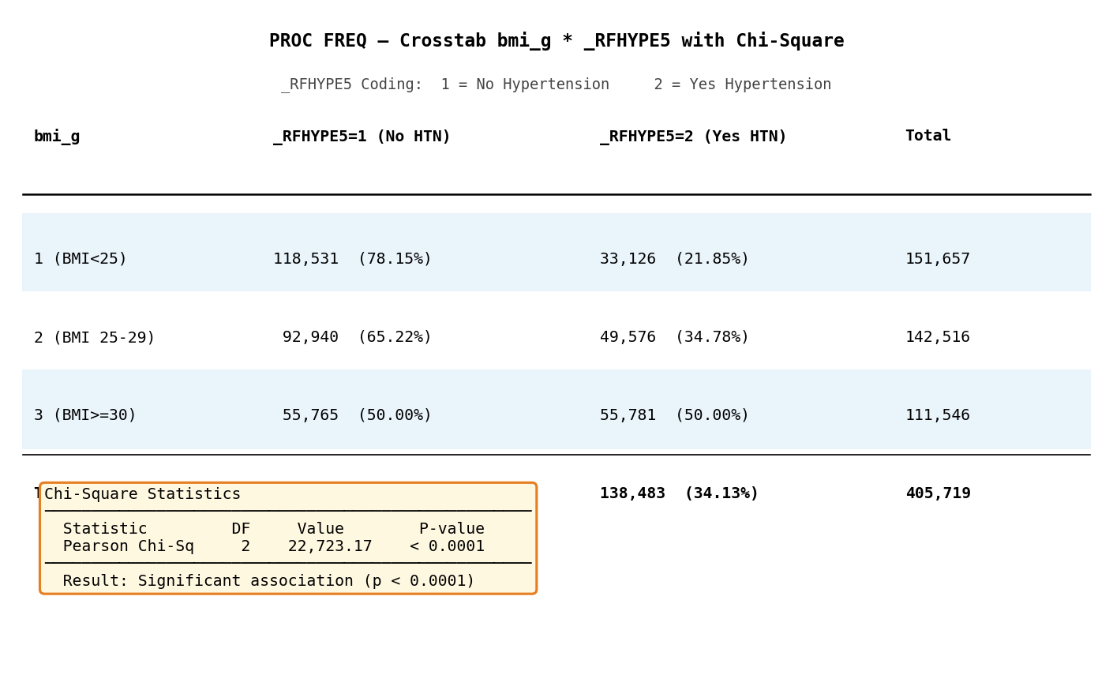
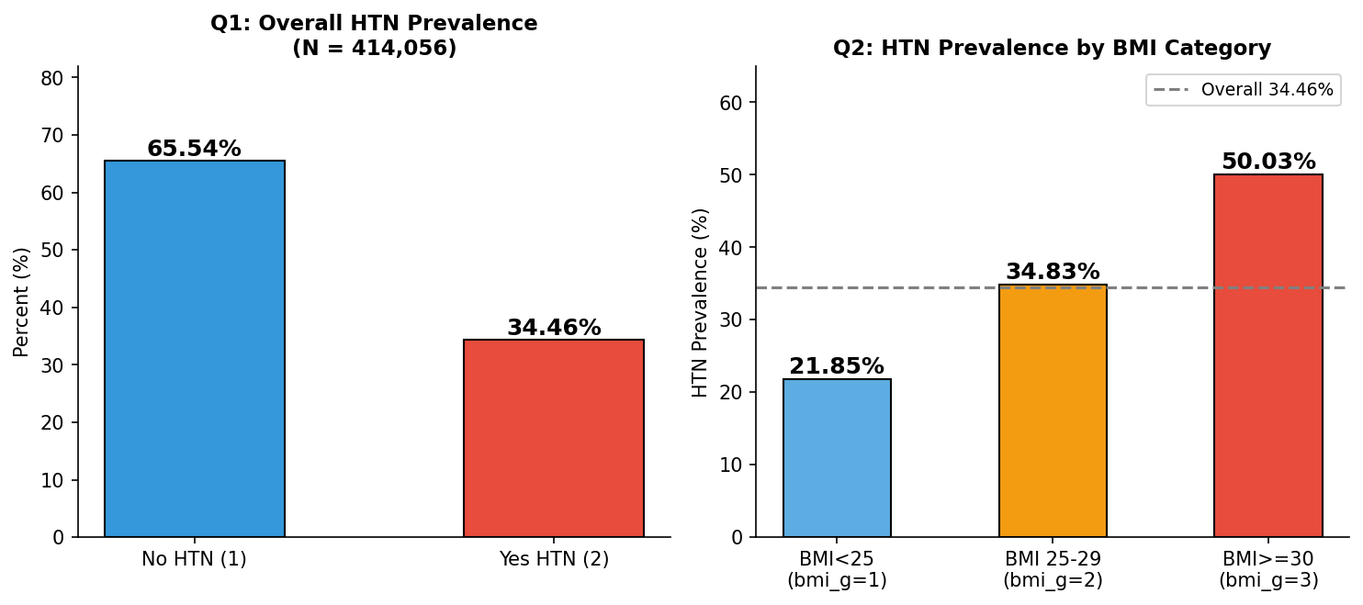
Codes
data sasdata_20191;
set brfss.sasdata_20191;
if _BMI5 = . then bmi_g = .;
else if 2500 > _BMI5 then bmi_g = 1; /***BMI less than 25***/
else if 2500 <= _BMI5 < 3000 then bmi_g = 2; /***BMI between 25 and 30***/
else if _BMI5 >= 3000 then bmi_g = 3; /***BMI greater than 30***/
run;

proc freq data=sasdata_20191 (where=(_RFHYPE5 < 7));
tables bmi_g * _RFHYPE5 / chisq;
run;

