SOC 100 Extra Credit Reflection: Institutionalizing History and Fostering Belonging
Name
Institution

Recently, I attended a Black History Month faculty panel at the Santos Manuel Student Union at Cal State San Bernardino as an audience member. Speakers such as Dr. Aaron Brown, Dr. Robert Jiles, and Dr. Brandon Gamble attended to celebrate the 100th anniversary of the Negro History Week which was established by Dr. Carter G. Woodson in 1926 to honor the contributions of the African Americans.¹
The most striking part of the panel was the use of this history as a practical, modern tool of student success and retention. In the presentation, one of the speakers pointed out that their teaching method is based on the teaching of biography and history by Carter G. Woodson. The event, rather than merely having students reflect upon the past, was an active promotion of Ethnic Studies that would bring a profound sense of belonging to the students in the universities. The emphasis on the principle of Umoja (unity) and the development of educational settings that could be regarded as a place of joy were truly inspiring.¹
This experience completely changed my perception of how communities negotiate through contemporary spaces. I used to consider Black History Month as a passive learning experience. But the revelation that Dr. Woodson not only designed it intentionally to create pride but also to realize that modern faculty can use it as an active, ongoing inclusion strategy made me understand that there is actually no time to lose in teaching cultural history.
This is directly related to our SOC 100 discussions on social institutions and identity. One of the key social institutions that influences the outcomes of society is the educational system. Through its proactive participation in the propagation of Ethnic Studies, the university employs its institutional structure to legitimize the marginal identities, as well as challenge the traditional power structure. By offering a space in which students perceive themselves in the cultural history of a curriculum, institutional belonging will be achieved, and the influence of changes in macro-level institutions on the micro-level personal identity will be evidenced.
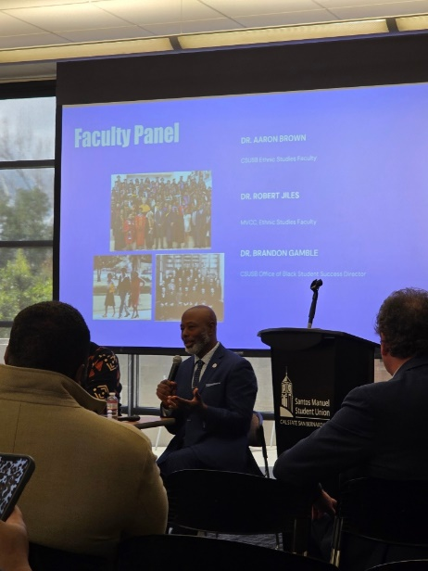
The photos below are photographs that I took during the faculty panel presentation as my required evidence of attendance at the event.

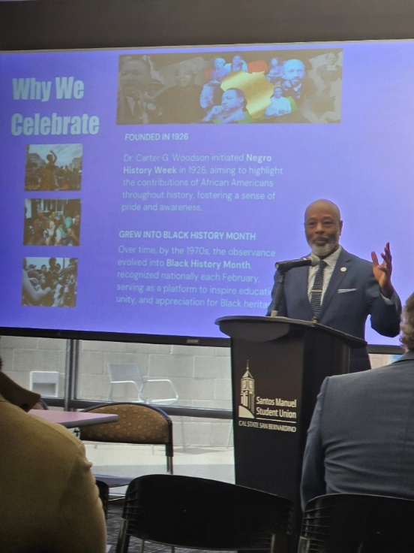
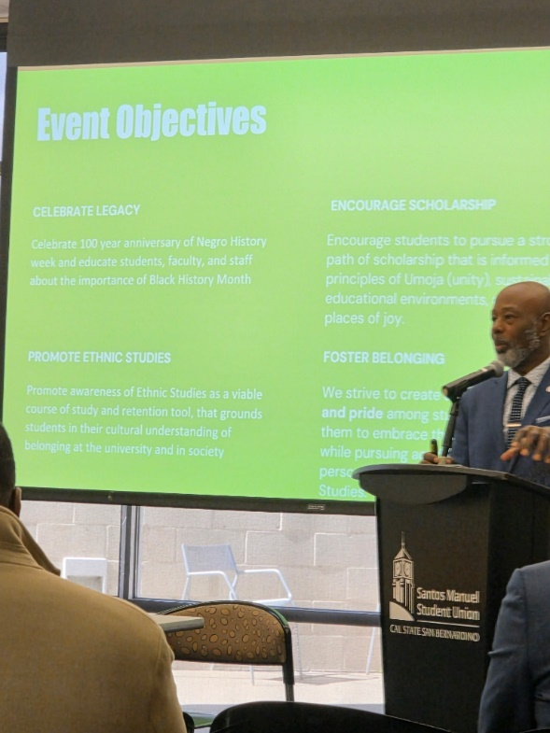

Reference List
- Gamble B, Brown A, Jiles R. Faculty Panel: Why We Celebrate and Event Objectives. Presentation at: Santos Manuel Student Union, Cal State San Bernardino; 2026; San Bernardino, CA.

