Between the Ward and the Home: Healthcare, Family, and Compounded Role Strain
During the COVID-19 Pandemic: Sociological Analysis: Part II — Institutional Intersection Written Analysis

Jose Torres
SOC 100
[Professor's Name]
[Institution Name]
April 27, 2026

Between the Ward and the Home: Healthcare, Family, and Compounded Role Strain
During the COVID-19 Pandemic: Sociological Analysis: Part II — Institutional Intersection Written Analysis

1. Introduction & Phenomenon
Two primary social institutions defining the life of individuals and social prosperity are considered to be healthcare and family. A set of professional hierarchies, biomedical values, and a logic of demand-at-all-costs all characterize healthcare, whilst a care worker is expected to take up any workload in the service of patient welfare. Cultural expectations of emotional attending and domestic caregiving that disproportionately burden women shape the family as an institution. Though these institutions work in different fields, they intersect in the lives of medical professionals occupying the front line, whose needs often come into conflict with those of all institutions.
The collision phenomenon that is explored here is the compounded role strain of healthcare workers (HCWs) in particular (and more so women) at the intersection of the healthcare institution and the family unit in the case of the COVID-19 pandemic. Role strain is defined as the tension that comes about when the duties that the one role requires are tension-inducing or draining to you. A structural conflict between professional and domestic roles would manifest as a compounded uncertainty situation that is well beyond the normal capacity of any individual to cope with. The hospital required optimum attendance, families required safeguarding, and proximity. These demands could not be reconciled in the eyes of the millions of workers who looked on.
The resultant levels of burnout in women HCWs had shot up to 56 percent in 2022 compared to 41 percent in men, with women simultaneously having the thrust sharply higher childcare burdens upon them (Nigam et al., 2023; Frank et al., 2021). Relationship disruption, higher levels of relationship anxiety, and secondary traumatic stress were reported by family members (Tekin et al., 2024). These outcomes are not the structurally predictable outcome of two institutions whose conflicting demands have never been developed to co-exist.
In this paper, I will argue that the collision of the two institutions (healthcare and family) in the pandemic environment resulted in compounded strain of roles, gender inequality, and indifferent burnout among medical staff, not due to personal incompetence, but due to structural hierarchies in hospitals and structural gender norms in families, which made equitable burden-sharing unattainable.
Table 1: Burnout and Mental Health Outcomes Among U.S. Healthcare Workers and Their Families (2022)
Worker Group | Burnout Rate | Poor MH Days/Month | Primary Driver
All HCWs | 19.0% | 4.5 days | Workload/short staffing
Women HCWs | 56% | ~6.0 days (est.) | Dual burden: work + care
Men HCWs | 41% | ~3.5 days (est.) | Workload/role conflict
HCW Family Members | N/A | Elevated (anxiety/depression) | Secondary traumatic stress
Note. Data from Nigam et al. (2023), Frank et al. (2021), and Tekin et al. (2024). HCW = healthcare worker. Women's burnout rate from Otuonye et al. (2022).

2. Theoretical Framework
The given analysis implements Conflict Theory as the main sociological prism. The Conflict Theory is based on the belief that society is structured around competing interests and unequal distributions of power, and that the institutions, instead of neutrality, reflect and reproduce the dominant group's advantages. Applying the Conflict Theory to the intersection between healthcare and family, it will become clear how hospitals extract labor out of workers, which is both racialized and classed, as well as being gendered. The advantage that the male-dominated hospital administrators enjoy is that the majority of nurses in the facility are women who have been socialized to provide a high standard of care to a patient without putting their own welfare or interests at risk.
This conflict became structurally apparent due to the pandemic. Gender inequality at work and at home is structurally related, as Yavorsky et al. (2021) reveal in a paper in Sociology Compass. The closing of schools and childcare facilities meant that most of the domestic labor has been reduced to women, even in dual-earner families. In the case of women HCWs, it translated to taking home with her two shifts of full-time work, then cleaning up hospital shifts. The healthcare facility that was influenced by a logic of worker sacrifice did not offer much accommodation.
Conflict Theory also drives the focus towards the people who establish the notion of legitimate grievance in healthcare. Women HCWs who either reported having experienced burnout or requested to have their hours reduced risked being marginalized as a profession, as institutional logic then equated dedication with self-sacrifice. This ideological operation stifles an acknowledgment of structural malady, asserting it as a matter of individual inadequacy. The perception of the healthcare-family intersection through this lens shows that role strain is not a failure by the individual or by different institutions, but rather a structural phenomenon that emanates from the power disparities within and between institutions.

3. Structure & Culture

Structural Dimensions
The institutional outlines of the healthcare-family interface are embedded in hospital policy, labor legislation, and professional standards. Healthcare facilities are typified by vertically ordered command lines wherein the frontline employees, namely nurses, aides, and paramedics, have practically no authority to decline assignments or negotiate for a change, without the threat of being subjected to retaliatory measures. In the context of COVID-19, such arrangements left the frontline workers without an institutionally valid way to protect their families: PPE was being rationed, moral distress was increasing steeply, and the gap between the ethical imperative and the institutionally permitted word grew extremely wider.
At the same time, the American family institution is strongly gendered and therefore reflects some deeply rooted gendered assumptions about domestic labor. The pandemic aggravated the previous inequalities: school closures and childcare shutdowns fell apart and destroyed the mechanisms of institutional support that had previously enabled women to pursue a career. Nigam et al. (2023) report that between 2018 and 2022, health workers reported that the number of days of poor mental health per month increased by 1.2 more days, and those who reported frequent burnout increased to 19.0% to 11.6% — fuelled by structural conditions, not individual plans.

Cultural Dimensions
These pressures were aggravated by cultural narratives in the two institutions. In healthcare, a self-sacrificing culture normalized expressions of exhaustion and setting boundaries. Within the family, where some level of maternal devotion was expected, women HCWs who voluntarily segregated themselves to avoid infection juggled between their feelings of guilt and institutional pressure. According to Hennein et al. (2023), women HCWs documented extensive gender discrimination during the pandemic, such as harassment when speaking of safety considerations, and being expected to handle domestic duties without institutional assistance. The combination of these cross-cultural scripts was that the full conformity of my life to both of these institutions was structurally impossible.

4. Social Inequality
The intersection of health care and family puts the victimization behind gender, racial/ethnic, and class. Women comprise about 76 percent of the healthcare workforce in the U.S. and over 85 percent of all nurses, which means that they are disproportionately exposed to both work-related risk and caregiving responsibility at home. In JAMA Network Open, a longitudinal study with a cohort of physician mothers, Frank et al. (2021) found that physician mothers were significantly more likely than physician fathers to report increased childcare burdens (59.2% vs. 29.8%), reduced work hours (19.4% vs. 8.5%), and new symptoms of anxiety or depression (7.2% vs. 3.1%) during the pandemic - after controlling the mental health of their mothers in the pre-pandemic period. These inequalities manifest structural gender inequality, but not individual differences.
Race/class borders on gender to create a more exposure-based situation. Black, Latinx, and immigrant women are disproportionately represented in the lowest-paid, highest-risk positions in healthcare — nurse aides, patient transporters, housekeeping staff, etc. — who were more exposed to COVID-19 with fewer institutional safeguards to rely on and fewer economic resources to cushion domestic impacts. Otuonye et al. (2022) have discovered that gender and marital status interact with structural factors to determine the trajectory or path of burnout, with women in healthcare consistently reporting a higher burnout index across all intersectional groups. Lower-paid HCWs, too, did not have the means to afford childcare substitutes, creating a structural trap where the institution's demands collided in the most violating way with those least equipped to absorb it.
Table 2: Gender Differences in Work-Family Conflict Among Physician Parents During COVID-19
Outcome | Women Physicians (%) | Men Physicians (%)
Increased childcare burden | 59.2% | 29.8%
Reduced work hours | 19.4% | 8.5%
Work primarily from home | 40.9% | 22.0%
New anxiety/depression | 7.2% | 3.1%

5. Interaction & Deviance
The collision of the institutions was enacted at the micro-level through the daily interaction determined by contradictory behavior scripts. The script of the hospital demanded maximum availability, emotional reflections, and emotionless caregiving; the family script demanded presence, warmth, and protective caregiving. Workers who were found between these scripts experienced role conflict - a condition where two or more roles are mutually incompatible. This was manifested by voluntary self-isolation of family members of many HCWs to prevent the spread of the virus - an action that was medically reasonable, but which contravened precise cultural values of family care and marital intercourse.
One example of the direct effect of the work-related stress of their HCW partner on the family is the study review by Tekin et al. (2024), who analyzed 20 studies about the experiences of families of HCWs. Children experienced anxiety linked with the risk of their parent becoming ill, and spouses reported experiencing emotional abandonment despite the physical presence of the HCW, but no emotional availability. These consequences are evidence of secondary deviance in the family institution, where normal occupational absenteeism became stigmatized as a dangerous exposure risk, reorganizing the meaning of dedication to work in the domestic sphere.
In the health sector, HCWs reporting burnout or seeking mental health care were at risk of sustaining social stigma. The cultural script of health invulnerability in codes of medicine contributes to help-seeking in codes of medical weakness interactions, deviance in hospitals. This stigma stopped rightful reporting of the suffering, thus making the scale of the crisis an invisible factor to institutional leadership until it is recorded in national surveillance data (Nigam et al., 2023).

6. Social Change
Role strain within the intersection of the healthcare and family has become a critical and longstanding social dilemma that has implications for patient safety, workforce sustainability, and gender equality. It would have to be addressed through a concerted reform of both institutions to work on the structural and cultural mechanisms pointed out in this paper.
Firstly, the healthcare organization must put in place the mandatory mental healthcare security of frontline workers. Nigam et al. (2023) show that positive working conditions, including supervisory support, ample time to finish work, and distrust in management, are individually linked to the significantly lower odds of burnout. It should be a binding policy, i.e., make hospitals a recipient of federal Medicare or Medicaid funds to comply with minimum staffing ratios, require mandatory paid mental health leaves, and provide other supportive and confidential help without the impact of professional ramifications.
Second, the government should invest in the family institution by offering universal childcare and subsidized childcare services in addition to paid family leave to essential workers. According to Yavorsky et al., the most pernicious gendered consequences of the pandemic were immediately due to the childcare closures - a permanent infrastructure would allow avoiding the appearance of similar effects in the future.
Third, gendered healthcare organizations should use gender-equity policies: flexible working hours, childcare on the workstations, and leadership training addressing the gendered assessment bias. Such reforms will follow a practical road towards equity in the interests of the workers who are the stoppers of the health system of the nation.

References
Frank, E., Zhao, Z., Fang, Y., Rotenstein, L. S., Sen, S., & Guille, C. (2021). Experiences of work-family conflict and mental health symptoms by gender among physician parents during the COVID-19 pandemic. JAMA Network Open, 4(11), e2134315. https://doi.org/10.1001/jamanetworkopen.2021.34315
Giddens, A., & Sutton, P. W. (2021). Essential concepts in sociology (3rd ed.). Polity Press.
Hennein, R., Gorman, H., Chung, V., & Lowe, S. R. (2023). Gender discrimination among women healthcare workers during the COVID-19 pandemic: Findings from a mixed methods study. PLOS ONE, 18(2), e0281367. https://doi.org/10.1371/journal.pone.0281367
Macionis, J. J. (2023). Sociology (17th ed.). Pearson.
Nigam, J. A. S., Barker, R. M., Cunningham, T. R., Swanson, N. G., & Chosewood, L. C. (2023). Vital signs: Health worker–perceived working conditions and symptoms of poor mental health — Quality of Worklife Survey, United States, 2018–2022. MMWR Morbidity and Mortality Weekly Report, 72(44), 1197–1205. https://doi.org/10.15585/mmwr.mm7244e1
Otuonye, G. C., Shenoi, N., Wu, T. D., Guntupalli, K., & Moukaddam, N. (2022). "I have nothing more to give": Disparities in burnout and the protective role of immigrant status during the COVID-19 pandemic. Frontiers in Public Health, 10, 994443. https://doi.org/10.3389/fpubh.2022.994443
Tekin, S., Nicholls, H., Lamb, D., Glover, N., & Billings, J. (2024). Impact of occupational stress on healthcare workers' family members before and during COVID-19: A systematic review. PLOS ONE, 19(9), e0308089. https://doi.org/10.1371/journal.pone.0308089
Yavorsky, J. E., Qian, Y., & Sargent, A. C. (2021). The gendered pandemic: The implications of COVID-19 for work and family. Sociology Compass, 15(6), e12881. https://doi.org/10.1111/soc4.12881

Video Op-Ed Transcript
"Between the Ward and the Home"
A Public Sociology Video Op-Ed | Approximate Runtime: 4 Minutes
Format: Video Op-Ed — Speaker addresses the camera directly with supporting on-screen visuals

Hook & Stakes
Each day, millions of healthcare professionals don their suits and get into hospitals and provide all that they have to offer to patients, to their own respective institutions, to a system that requires one hundred percent dedication. However, by the time the shift has ended and they have gone back home to their family, many of them are facing a second institution at home: family. Submerging in COVID-19, there was a collision between those two worlds. And the collision did not fall equally. One thing that fell on women the hardest is hard.
Visual 1
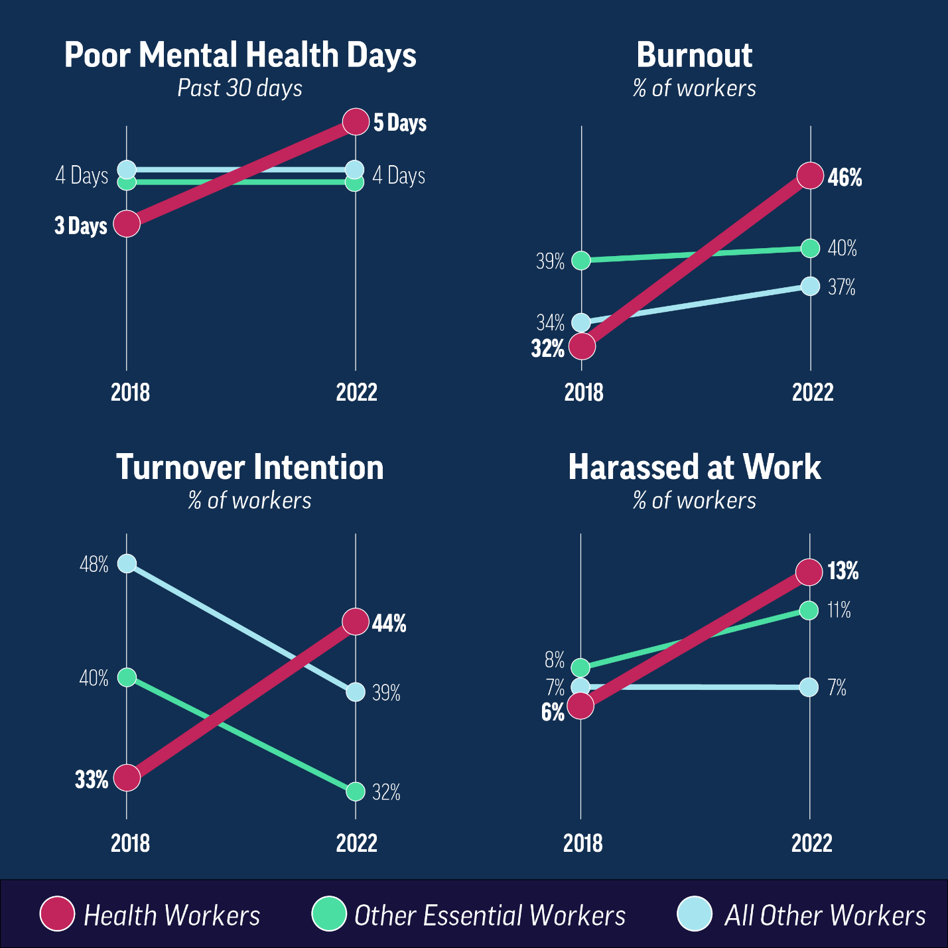
Figure 1. CDC/NIOSH Vital Signs Infographic: "Health Workers Face a Mental Health Crisis," 2023.
Formal CDC information graphic provided by the Nigam et al. (2023) report on the vital signs of the MMWR. Expenses burnout rates, harassment, turnover intentions, comparing 2018-2022, by 2022, almost half of health workers reported frequent burnout. Display on the Hook segment.
Source: Nigam et al. (2023), MMWR, 72(44). https://doi.org/10.15585/mmwr.mm7244e1. Public domain. Available at: https://www.cdc.gov/vitalsigns/health-worker-mental-health/index.html

Defining the Intersection
In sociology, we have a name for this: role strain. That is what occurs when two institutional roles are pulling apart, and neither side of the institution can take the strain. The hospital would not allow patients to be understaffed. Your children require you, and the school has been shut for months. There is no satisfactory answer. It is just the individual at the centre of taking the burden.
Surveys published in the review, such as those by Yavorsky, Qian, and Sargent in Sociology Compass, show that the pandemic did not establish any gender inequality in work and family — it increased the existing inequalities. The weight was put on women when childcare and schools shut down. By having those women also be nurses and physicians, they were expected to be present in two places at once, without the recognition of the institution that this was impossible (Yavorsky et al., 2021).

Evidence
In 2022, 56 % of women healthcare workers reported burnout - in comparison to 41 percent of men. According to a federal study, the percentage of workers identifying as having frequent burnout had risen by four years (11.6 percent) to 19 percent due to workload and worsening conditions (Nigam et al., 2023). These are individuals who did not surrender. These are individuals who have been systematically predetermined to fail.
Visual 2
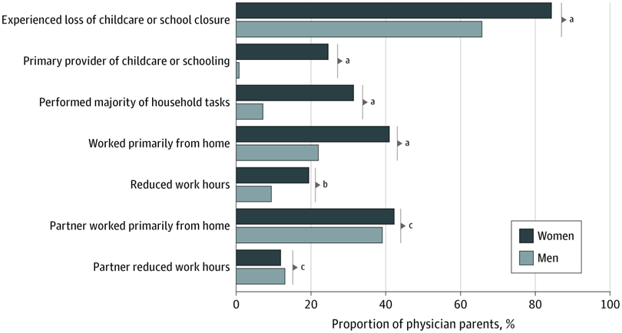
Figure 2. Family and Work Experiences of Physician Parents by Gender During COVID-19.
Figure 1 of the article by Frank et al. (2021) in JAMA Network Open (open access, CC-BY). Combined bar charts to compare physician mothers and fathers on childcare responsibility, household activities, working remotely, and with fewer hours. Mothers reported significantly higher rates on each of the measures - e.g., 24.6 vs. 0.8 on childcare. Screen in Testimony section. Source: Frank et al. (2021), JAMA Network Open, 4(11), e2134315. https://doi.org/10.1001/jamanetworkopen.2021.34315. Retrieve from: https://jamanetwork.com/journals/jamanetworkopen/fullarticle/2786027

Inequality Mechanism
Almost 76 % of the healthcare workforce in the U.S. is comprised of women, with more than 85 percent of nurses being women. At their workplaces, they are most likely to be affected by COVID-19, whereas at home, they are most likely to absorb the fallout of COVID-19. When they raised issues related to safety deficits or childcare they have been shown to have often been dismissed, because the organizational culture of healthcare equates professional obligation with self-sacrifice. And even families had to pay. A systematic review of twenty studies discovered that HCW family members were experiencing elevated distress levels and had adopted heavier domestic burden loads that were directly linked to the occupational distress levels of their loved one (Tekin et al., 2024).

Social Change
There are three reforms that are required. First, require healthcare workers to take paid mental health leave - no working penalty, no label. Second, develop a universal childcare infrastructure that is permanent. When the schools get closed, the ladies suffer a loss in their careers and well-being. Third, direct the hospitals to undertake gender-equity audits. By whom is it that protection is being safeguarded? To whom does one promote? And who of bearers bears a twofold burden silently? These inequalities were not developed within the context of the pandemic. It exposed them. The initial step of change is exposure.
Visual 3
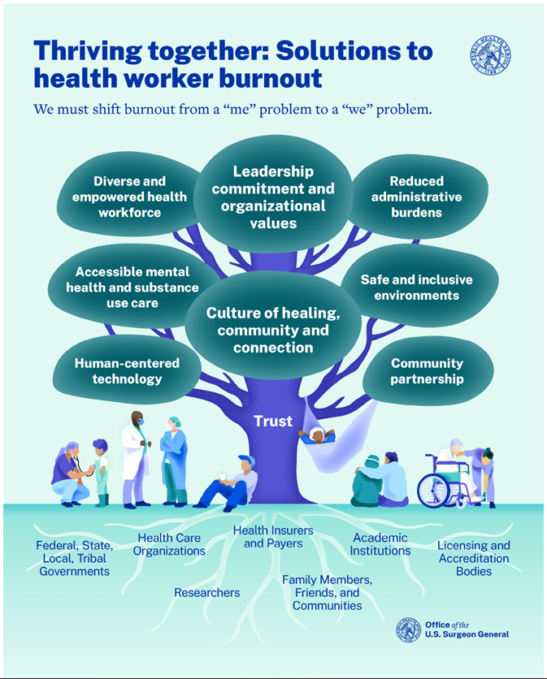
Figure 3. U.S. Surgeon General's Advisory: "Addressing Health Worker Burnout," 2022.
Official cover of the HHS Surgeon General's Advisory on Building a Thriving Health Workforce. The report supports institutional and policy reformation in order to mitigate burnout - endorsing the proposals in the U.S. public health Social Change section of this video at the highest level of authority in American society. Display during Social Change and Closing. Source: U.S. Department of Health and Human Services (2022). Public domain. https://www.hhs.gov/sites/default/files/health-worker-wellbeing-advisory.pdf

Closing
Two of the institutions presented absolute demand on the same individuals. Neither constructed a bridge between these requirements. Contrary to the expectations of the time, the persons in the squeeze were almost exclusively female. No coincidence that. That is a tendency--and the tendencies created by institutions are alterable by institutions. Having sociology is what it is all about.
— End of Transcript —

References
Frank, E., Zhao, Z., Fang, Y., Rotenstein, L. S., Sen, S., & Guille, C. (2021). Experiences of work-family conflict and mental health symptoms by gender among physician parents during the COVID-19 pandemic. JAMA Network Open, 4(11), e2134315. https://doi.org/10.1001/jamanetworkopen.2021.34315
Nigam, J. A. S., Barker, R. M., Cunningham, T. R., Swanson, N. G., & Chosewood, L. C. (2023). Vital signs: Health worker–perceived working conditions and symptoms of poor mental health — Quality of Worklife Survey, United States, 2018–2022. MMWR Morbidity and Mortality Weekly Report, 72(44), 1197–1205. https://doi.org/10.15585/mmwr.mm7244e1
Tekin, S., Nicholls, H., Lamb, D., Glover, N., & Billings, J. (2024). Impact of occupational stress on healthcare workers' family members before and during COVID-19: A systematic review. PLOS ONE, 19(9), e0308089. https://doi.org/10.1371/journal.pone.0308089
U.S. Department of Health and Human Services. (2022). Addressing health worker burnout: The U.S. Surgeon General's Advisory on building a thriving health workforce. https://www.hhs.gov/sites/default/files/health-worker-wellbeing-advisory.pdf
Yavorsky, J. E., Qian, Y., & Sargent, A. C. (2021). The gendered pandemic: The implications of COVID-19 for work and family. Sociology Compass, 15(6), e12881. https://doi.org/10.1111/soc4.12881

