Do Probiotics Really Work?

Student Name
Section Number

Do Probiotics Really Work?
Probiotic items have established themselves as a commonplace presence in the current consumer health markets, with annual revenues in the global marketplace estimated in the billions of dollars, and an annual rate of growth that shows little evidence of its ability to slow its pace of growth. Offered in capsule supplements, as well as fermented dairy drinks, these products have been marketed both to healthy and unhealthy populations in the marketplace. According to the International Scientific Association of Probiotics and Prebiotics, probiotics can be defined as living microorganisms that, when ingested in sufficient doses, provide a health benefit to the host (NIH, 2020). These microorganisms (primarily bacteria, but also yeasts) are found in some fermented foods (e.g., yogurt) and are added to certain food products and are available as dietary supplements. However, not all foods and dietary supplements that are labeled as probiotics have proven health benefits. Probiotics represent a legitimate, but narrowly-focused clinical intervention whose efficacy is not dictated by general consumption but rather by the exact match of strain, dose, condition, and patient groups - and although strong evidence indicates its effectiveness in antibiotic-associated diarrhoea, irritable bowel syndrome, and ulcerative colitis, the science does not justify the population-wide advocacy routinely implied by commercial marketing.

Probiotic Action Mechanisms
The action of probiotic bacteria and a variety of beneficial yeasts produces their effects via an overlapping set of physiological mechanisms, which explains both the therapeutic potential of these bacteria and yeasts and their variability across different conditions. Merenstein et al. (2024) confirm that probiotics compete with pathogenic organisms in seeking adhesion sites on the intestinal epithelium, restricting colonisation by harmful bacteria. They also ferment non-digestible dietary fibres to produce short-chain fatty acids (SCFA)- primarily butyrate, propionate and acetate- which are the major source of energy to intestinal epithelial cells and enhance barrier integrity by increasing tight junction proteins such as occludin and claudin. All these mechanisms result in decreased permeability of intestinal luminal epithelial cells (CEC), which is a pathophysiological characteristic of many conditions, including antibiotic-associated diarrhoea (AAD), irritable bowel syndrome (IBS), and inflammatory bowel disease (IBD) (Mazziotta et al., 2023). The fact that some probiotic interventions are successful and others fail is easily understood in terms of the pathways involved; the mechanisms are physiologically plausible, and it is simply a matter of time and experience to work out which ones can and cannot be colonised and maintained by a particular host gut. Such understanding of mechanics therefore proves that the benefits of probiotics can indeed have legitimate biological pathways and mechanisms through which they can manifest benefits, and also explains why the effects of probiotics in one strain, which has been successfully tested on another strain, cannot be generalized to the other strain.
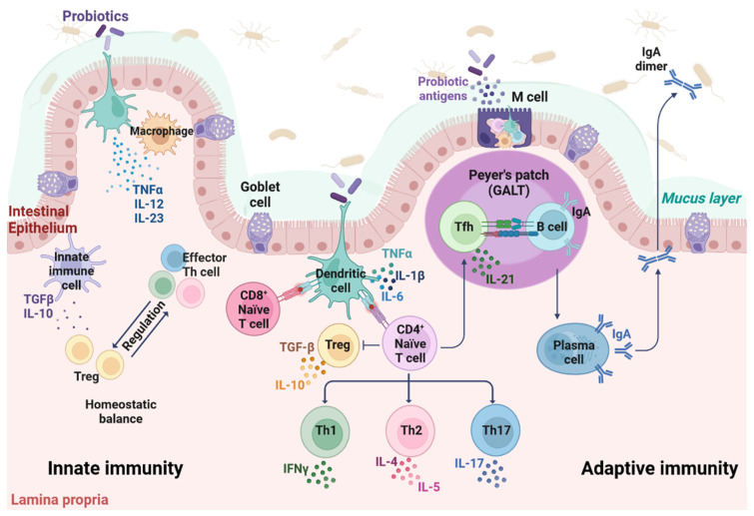
Figure 1. Mechanism of probiotic action (Sourced from Mazziotta et al. 2023)
The second key mechanism is that of immunomodulation. The Probiotic organisms have an interaction with the gut-associated lymphoid tissue (GALT), the largest immune organ in the body, which promotes the action of regulatory T-cells that shift the cytokine environment towards an anti-inflammatory state, characterised by increased interleukin-10 and a decrease in tumour necrosis factor-alpha. A study identify immune-regulatory effect as central to the therapeutic effects observed in the trials of probiotic treatment in ulcerative colitis: those in which Bifidobacterium species and the multi-strain formulation VSL3 were used (Ma et al., 2024). This process is not only a biological curiosity but also a direct explanation of the ability of probiotics to reduce inflammation of the intestinal mucosa at the clinical level, because they work by restoring an interrupted balance of the immune system, and not pharmacologically in their action. This makes probiotics truly disease-modifying in disease states of gut dysbiosis, should the appropriate strain be matched to the disease condition.

Where Clinical Evidence is Strongest
Antibiotic-Associated Diarrhoea
Prevention of antibiotic-associated diarrhoea is the best and most clinically significant complication of broad-spectrum antibiotic therapy, affecting up to 30% of all treated patients. A study assessed Lactobacillus acidophilus LA85 of 2 × 109 colony-forming units of representatives of their respective strains each day in adult patients receiving amoxicillin (Zhu et al., 2025). The trial found that the LA85 supplementation significantly reduced the duration of the diarrhoea episodes compared to the diarrhoea episodes of the probiotic group, which were found to be significantly less variable. The main treatment results of this trial are relevant because these results show evidence of strain-level testing under rigorous experimental conditions: results were objective and of clinical value to the treatment. The mechanism is that Lactobacillus strains recolonise the disrupted microbiome, resume SCFA production that antibiotics inhibited, and competitively exclude opportunistic organisms, such as Clostridioides difficile, before it has a chance to dominate. And this is probiotics as it were, in a clear clinical situation, via a clear biological pathway.
Irritable Bowel Syndrome
Irritable bowel syndrome is a highly common functional gastrointestinal disorder, with abdominal pain, bloating and changed bowel habits, and has a prevalence of 10-15 percent of the world population. Its known pathophysiological characteristics include gut dysbiosis, changes in intestinal permeability and gut-brain axis dysregulation - all of which probiotics have been shown to have a positive effect on. A study found a medium effect size for the global IBS symptom improvement in probiotics compared to placebo (Chen et al., 2023). The size of this effect is of clinical significance in a disease where there are limited pharmacological solutions available. Notably, Chen et al. (2023) have also found that shorter treatment length, less than four weeks and Bacillus-genus probiotics resulted in larger effect sizes, which is how the effect of probiotics is known to be both strain-specific and dose-duration-dependent. This result adds to and contextualises previous systematic review results and has a direct impact on clinical practice: when prescribing probiotics in IBS, the strain and the treatment regimen must be thoughtful and not generic. The evidence confirms IBS to be a condition under which probiotics can indeed have a real-life symptomatic impact, namely on abdominal pain and bloating, and where the biological processes SCFA production, barrier reinforcement, immune calibration are directly operative.
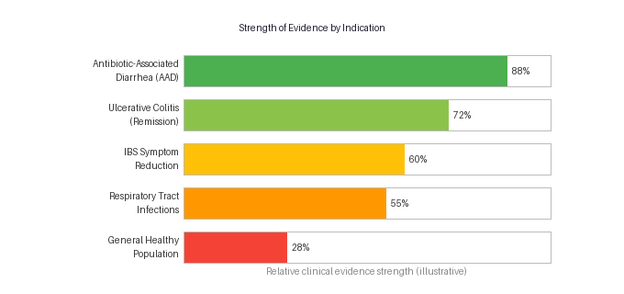
Figure 2. Relative strength of clinical evidence of probiotic use in major indications (adapted from Merenstein et al., 2024; Ma et al., 2024; Chen et al., 2023)
Selection of strains in probiotic treatment of irritable bowel syndrome cannot be interchangeable the clinical evidence will require a specific probiotic to administer to match a targeted symptom. Xie et al. (2023) further sculpt the iceberg by comparing the outcome-specific efficacy of various probiotic strains and combinations. No single strain was found to be better across all IBS outcome dimensions: various strains were found to be better in abdominal pain, bloating and global symptom ratings independently (Xie et al., 2023). The clinical implication is obvious: a patient with pain as the primary symptom should be prescribed another strain compared to the patient with bloating as the primary symptom. This accuracy is not found in the vast majority of commercial probiotic products, which market with a condition or symptom-specific lack of evidence, or generic multi-strain formulations. The Fit to the central thesis is this: the evidence indicates that probiotics do work in IBS, but that the one-size-fits-all model of consumer probiotics does not work well with this evidence base.
Inflammatory Bowel Disease
Probably because of its selective effect, the evidence of probiotics on inflammatory bowel disease is more selective than on IBS or AAD, yet remains clinically relevant to ulcerative colitis. A review of clinical studies indexed in PubMed, Embase, the Cochrane Library, and Web of Science as part of a systematic review published in the Open Biology found strong evidence that supports the use of Escherichia coli Nissle 1917 in maintaining UC in remission and the use of Bifidobacterium species and VSL1917 to induce remission in mild-to-moderate active UC. It was found that these trials were of a direct working nature in regard to the mechanisms, which were reduced oxidative stress in inflamed mucosa, restoration of tight junction protein expression and anti-inflammatory cytokine modulation. This fact supports the point that probiotics could be used as disease-modifying agents in UC, rather than as supporting supplements. Nevertheless, Ma et al.(2024) are also unequivocal that the evidence of Crohn disease is still inconclusive, and that definitive clinical conclusions can not be drawn based on current RCTs. This difference within a single disease entity, strong evidence in UC, weak evidence in CD, is an example of a much larger principle that runs through the entire literature regarding probiotics: the limits to effective clinical use are narrow and must not be generalised.

Limitations and the Boundaries of the Evidence
The most impactful shortcoming of the probiotic evidence base is the consistent inability to differentiate between strains. Wu et al. (2024) found that the use of Bifidobacterium and Lactobacillus strains was consistently found to be better than placebo in improving the symptoms of IBS, yet the effect sizes varied significantly based on the specific strain and combination used. More importantly, their analysis points to the fact that strains collected at the genus level, as is often the case in consumer products, cannot be assumed to be similarly efficacious simply because they are collectively found at the genus level. This discovery reiterates a basic issue running through the probiotic literature (meta-analyses that pool together different strains of probiotics) inflate apparent efficacy estimates by conflating highly efficacious strains with ineffective ones. The implications on consumers are severe: most commercial products containing probiotics have not been tested in RCTs, and evidence generated to date using strains studied in clinical trials, such as Lactobacillus rhamnosus GG or Saccharomyces boulardii CNCM I-745, cannot be applied legally or scientifically to strains that have not been studied in clinical trials, such as those found in retail supplements.
The second and also critical limitation deals with the evidence in healthy populations - the demographic comprising the greatest portion of probiotic consumers in the world. This question was the specific one that authors approached, applying to it the evidence standards of the United States Preventive Services Task Force (USPSTF) to determine whether probiotics should be recommended to the general population to prevent diseases (Merenstein et al., 2024). Their recommendation was clear: although there is enough evidence of efficacy and safety to consider specific probiotics for specific indications, such as preventing AAD and reducing respiratory tract infections in certain subgroups, the available evidence does not justify blanket, population-wide recommendations. Importantly, Merenstein et al. (2024) point out that the lack of evidence regarding the effectiveness is not equivalent to its ineffectiveness, which is relevant due to the relatively new nature of the probiotic research field. This is an important distinction between the healthy general population, where something has a strong likelihood of being shown to be ineffective, and that would be characterized as proven ineffective. This uncertainty must be negotiated by consumers and clinicians alike without throwing oneself into the forces of blanket advocacy or blanket dismissal.

Conclusion
Probiotics are a valid albeit rather limited clinical intervention that relies not on a general intake but on a strict combination of strain, dose, condition and patient population to yield a positive therapeutic outcome. The data discussed in this assignment support the claim that certain probiotic strains have actual, quantifiable effects in antibiotic-related diarrhoea, irritable bowel syndrome, and ulcerative colitis - outcomes obtained via the combination of coherent biological processes, including the production of short-chain fatty acids, the fortification of the intestinal barrier, and immunomodulation. They are not speculative arguments; they are the results of randomised controlled studies and systematic reviews, carried out with the most stringent methodology. Nevertheless, the body of evidence is independent that efficacy is strain-specific, that results cannot be generalised across strains or conditions and that preventive use in healthy populations is not supported in terms of population effects.

References
Chen, M., Yuan, L., Xie, C.-R., Wang, X.-Y., Feng, S.-J., Xiao, X.-Y., & Zheng, H. (2023). Probiotics for the management of irritable bowel syndrome: A systematic review and three-level meta-analysis. International Journal of Surgery, 109(11), 3631–3647. https://doi.org/10.1097/JS9.0000000000000658
Ma, Y., Yang, D., Huang, J., Liu, K., Liu, H., Wu, H., & Bao, C. (2024). Probiotics for inflammatory bowel disease: Is there sufficient evidence? Open Life Sciences, 19(1), 20220821. https://doi.org/10.1515/biol-2022-0821
Mazziotta, C., Tognon, M., Martini, F., Torreggiani, E., & Rotondo, J. C. (2023). Probiotics Mechanism of Action on Immune Cells and Beneficial Effects on Human Health. Cells, 12(1), 184. https://doi.org/10.3390/cells12010184
Merenstein, D. J., Tancredi, D. J., Karl, J. P., Krist, A. H., Lenoir-Wijnkoop, I., Reid, G., Roos, S., Szajewska, H., & Sanders, M. E. (2024). Is There Evidence to Support Probiotic Use for Healthy People? Advances in Nutrition, 15(8), 100265. https://doi.org/10.1016/j.advnut.2024.100265
NIH. (2020). Probiotics: Fact sheet for health professionals. https://ods.od.nih.gov/factsheets/Probiotics-HealthProfessional/
Wu, Y., Li, Y., Zheng, Q., & Li, L. (2024). The Efficacy of Probiotics, Prebiotics, Synbiotics, and Fecal Microbiota Transplantation in Irritable Bowel Syndrome: A Systematic Review and Network Meta-Analysis. Nutrients, 16(13), 2114. https://doi.org/10.3390/nu16132114
Xie, P., Luo, M., Deng, X., Fan, J., & Xiong, L. (2023). Outcome-Specific Efficacy of Different Probiotic Strains and Mixtures in Irritable Bowel Syndrome: A Systematic Review and Network Meta-Analysis. Nutrients, 15(17), 3856. https://doi.org/10.3390/nu15173856
Zhu, J., Sun, Y., Dong, Y., Zhao, Y., Gai, Z., & Fang, S. (2025). Efficacy and Safety of Lactobacillus acidophilus LA85 in Preventing Antibiotic‐Associated Diarrhea: A Randomized, Placebo‐Controlled Study. Food Science & Nutrition, 13(6), e70490. https://doi.org/10.1002/fsn3.70490

