Assignment 7
PH631
- Draw the geographic map for adjusted prevalence of having coronary heart disease or myocardial Infarction using BRFSS dataset in 2019 and discuss the patterns over different states.
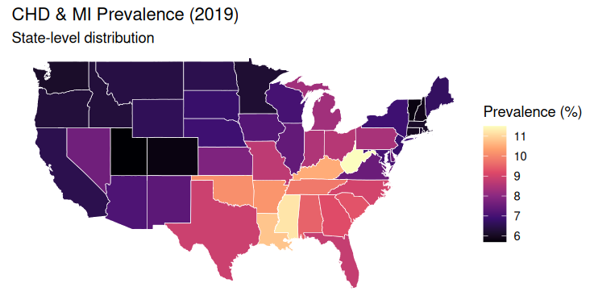
- Read the paper, titled “ Obesity as an Independent Risk Factor for Cardiovascular Disease: A 26-year Follow-up of Participants in the Framingham Heart Study, and answer the following questions:
- What did they use as a measurement of obesity? How is measured ? Be specific

Measure of Obesity

The Metropolitan Relative Weight (MRW) was applied in this research to measure obesity.
The calculation of MRW is based on Metropolitan Life Insurance company data and is an index of weight expressed as a percentage of "ideal weight."
Calculation formula:
MRW = (Actual Body Weight ÷ Desired Body Weight for Height) × 100
Procedure of measurement:
Weight and height (in pounds and inches respectively) of each subject were recorded.
Data of the standard reference tables of "ideal weight" according to sex, age, and height were employed for comparison.
The result was presented using a percentage.
Results interpretation
The MRW is considered normal at 100%, overweight at 110%, and markedly obese if MRW ≥ 130%.
Consequently, as opposed to BMI, obesity was measured as relative excess body weight compared to a reference group.
- What is the crude incidence of coronary heart disease? What are the crude incidence of coronary heart disease by women and man, respectively. Show your work that how they were estimated based on the numbers provided in the article

Formula for crude incidence of coronary heart disease (CHD):
Total number of participants
The number of CHD patients

(a) Male
Total males = 2197
Number of CHD patients among males = 636

= 0.2895 ✏ Result:

The crude incidence among men = 28.95% or ~29.0%.

(b) Female
Total females = 2714
Number of CHD patients among females = 437

= 0.1610 ✏ Result:

The crude incidence among females = 16.10%.

(b) Total crude incidence
Number of participants in total = 2197 + 2714 = 4911
Total number of CHD patients = 636 + 437 = 1073

= 0.2185 ✏ Result:

Total crude incidence = 21.85%

Conclusion
The incidence of CHD was significantly higher among men (29%) compared to women (16%).
This suggests that men in the cohort have a greater underlying risk of heart disease.
- Based on the results in the figure3, Create a table to show the estimated Relative Risk of coronary heart disease by the level of MRW(< 110, 110-119, >130+) and by sex and provide an interpretation of the finding.

The Metropolitan Relative Weight (MRW) was categorized into three categories according to the trend lines in Figure 3 of the Framingham study: <110% (normal weight), 110–119% (overweight), and ≥130% (obesity). The reference category (RR = 1.0) was the low category (<110%). As the level of the MRW increased, it elevated the relative risk (RR) of developing coronary heart disease (CHD) in both males and females. In males, the RRs were 1.3 in the 110–119% group and about 1.8–2.0 in the ≥130% group while in females, they were 1.2 and about 2.0–2.3, respectively. Therefore, it can be concluded from these results that there was an evident dose-response pattern with increasing body weights associated with higher risks of CHD. However, the risk increase was highest among those who were classified as obesity (≥130%), where in females, the risk more than doubled whereas it nearly doubled in males. Moreover, when the MRW values were high, there were relatively larger increases in risk in women compared to men. More importantly, all these associations were statistically significant even after adjustment for confounding factors such as age, blood pressure, cholesterol, smoking, and glucose intolerance.

