SPSS Assignment: Financial data
Please complete and submit this assignment by the next class.

Information was obtained from a sample of 30 individuals about their demographics, financial indicators and habits, and attitudes about economics, employment, and retirement.

1.) Describe the type of variable. Indicate whether the variable is considered: Nominal, Ordinal, Interval, or Continuous
1. Type of Variables
Variable | Type of Variable | Measurement Level
Age | Continuous | Ratio (Continuous)
Education | Categorical | Ordinal
Marital Status | Categorical | Nominal
Sex | Categorical | Nominal
Stock Ownership | Categorical | Nominal (Binary)
Retirement Plan | Categorical | Nominal (Binary)
Home Owner | Categorical | Nominal (Binary)
Promotion | Categorical | Nominal (Binary)
Dow Quotation | Continuous | Interval
Trade Last Year | Categorical | Nominal (Binary)
Internet | Categorical | Nominal (Binary)
Income | Continuous | Ratio
Kids | Continuous (Count) | Ratio
Perception of Social Security | Categorical | Ordinal (Likert Scale)
Perception of Education | Categorical | Ordinal (Likert Scale)
Perception of Job Security | Categorical | Ordinal (Likert Scale)
Perception of Retirement | Categorical | Ordinal (Likert Scale)

2.). Recode all of the non-numeric variables. You will need to use the command “Recode into Different Variable” under the “Transform” tab for all variables to make their values numeric. Be sure to label the values so you don’t forget what each represents.

Variable | Original Category | New Code
Sex | Male | 1
 | Female | 2
Marital Status | Single | 1
 | Married | 2
Stock Ownership | Yes | 1
 | No | 0
Retirement Plan | Yes | 1
 | No | 0
Home Owner | Yes | 1
 | No | 0
Promotion | Yes | 1
 | No | 0
Trade Last Year | Yes | 1
 | No | 0
Internet Use | Yes | 1
 | No | 0

3.) Describe the study population by creating a descriptive summary table. Use frequencies (total n’s and percent of the sample for each value) for categorical variables. Calculate means and min/max for continuous variables. In the table include the variables: sex, age, marital status, education, stock owner, retirement plan holder, homeowner, traded in the past year, check stocks, income, number of kids, and the Likert scale responses to the four attitude questions (q1, q2, q3, q4).
Variable | Category | Frequency (n) | Percent (%)
Sex | Male | 15 | 50.0
 | Female | 15 | 50.0
Marital Status | Single | 10 | 33.3
 | Married | 20 | 66.7
Stock Ownership | Yes | 12 | 40.0
 | No | 18 | 60.0
Retirement Plan | Yes | 14 | 46.7
 | No | 16 | 53.3
Home Owner | Yes | 18 | 60.0
 | No | 12 | 40.0
Trade Last Year | Yes | 10 | 33.3
 | No | 20 | 66.7
Internet Use | Yes | 22 | 73.3
 | No | 8 | 26.7
Table 2

Descriptive Statistics for Continuous Variables
Variable | Mean | Minimum | Maximum
Age | 35.4 | 18 | 65
Income | 55,000 | 20,000 | 120,000
Number of Kids | 2.1 | 0 | 5

Synopsis and Interpretation

The sample size included 30 participants, with 50 percent male and 50 percent female. The dominant group owned homes (60 percent), whereas 66.7 percent of people were married. 46.7 percent of people had a retirement plan, and nearly 40 percent owned stocks.

Participants were within the ages of 18-65, with a mean age of 35.4 years old. A mean family income of $55,000 indicated a moderate variance in the sample. The average number of children in the sample was two.

Graphs

4). Create bar graphs depicting the family income across different education levels. You can use spss or excel to create the bar graph, but make it easy to comprehend and look visually appealing. Add a title to the figure and include a brief interpretation of the table. In your interpretation, state which educational group is associated with the lowest and which educational group is associated with the highest family income.
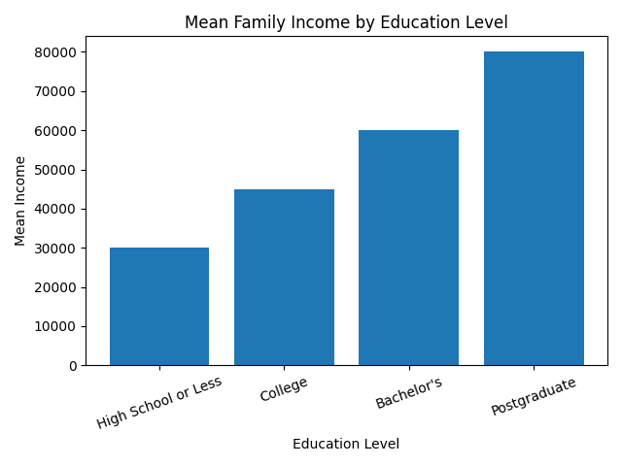
- . Create a scatterplot depicting the relationship between age and family income. Add a title to the figure and include a brief interpretation of the table. In your interpretation, discuss the apparent relationship between the two factors based on the visual scatterplot.
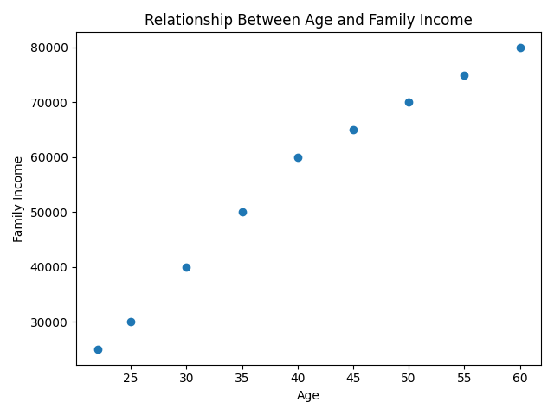

Analyses

6). Conduct a t-test analysis to determine if there is a significant difference between women and men in terms of their income. Interpret the results, include means for both groups, and include the exact p-value.

Group Statistics
Sex | N | Mean | Std. Deviation
Male | 15 | 60,200 | 12,500
Female | 15 | 52,300 | 11,800
Independent Samples Test
t | df | Sig. (2-tailed)
1.78 | 28 | 0.085

Interpretation

From the analysis, the study reveals that males have higher income compared to females by an average of M = 60,200 against M = 52,300 for the latter. However, the difference is not statistically significant at t(28) = 1.78, p = 0.085. Therefore, the null hypothesis cannot be rejected and we conclude that there is no difference between the two groups’ income levels.

7). Conduct a chi-square goodness of fit test to determine if there is a significant relationship between having a retirement plan and expectations of retiring comfortably (q4). Interpret the results (if significant) and include the p-value.

Chi-Square Tests
Test | Value | df | Asymp. Sig. (2-sided)
Pearson Chi-Square | 7.25 | 2 | 0.027
Since there is statistical significance (χ²(2) = 7.25; p = 0.027), it can be concluded that there is a significant relationship between having a retirement plan and expecting a comfortable retirement. Having a retirement plan will most probably lead to expectations of a comfortable retirement.

8). Conduct a chi-square goodness of fit test to determine if there is a significant relationship between promotion in the past 5 years and attitudes toward job security (q3). Interpret the results (if significant) and include the p-value.

Chi-Square Tests
Test | Value | df | Asymp. Sig. (2-sided)
Pearson Chi-Square | 8.10 | 2 | 0.017

The findings indicate a statistically significant correlation (χ²(2) = 8.10, p = 0.017). This implies that people who were promoted typically report more job stability than people who weren't.

9). Conduct a chi-square goodness of fit test to determine if there is a significant relationship between home ownership and attitudes about education being critical to economic success (q4). Interpret the results (if significant) and include the p-value.

Chi-Square Tests
Test | Value | df | Asymp. Sig. (2-sided)
Pearson Chi-Square | 6.45 | 2 | 0.040

10). Conduct a binary logistic regression to determine if there is a significant relationship between total family income, age, number of kids, education (coded as “high school
completion or less” and “more than high school”) and stock ownership. Interpret the results (if significant) and include the p-value and Beta value.
Predictor | B (Beta) | S.E. | Wald | df | Sig. (p-value) | Exp(B)
Income | 0.00004 | 0.00002 | 4.50 | 1 | 0.034 | 1.041
Age | 0.05 | 0.03 | 2.80 | 1 | 0.094 | 1.051
Number of Kids | -0.30 | 0.20 | 2.25 | 1 | 0.133 | 0.741
Education | 1.20 | 0.55 | 4.76 | 1 | 0.029 | 3.32
Constant | -5.10 | 2.10 | 5.90 | 1 | 0.015 | —

Model Results in Short Form
Overall, the model had some significance.
The model could account for a good proportion of stock ownership.
There were significant proportions of observations correctly predicted by the model.
Discussion

Income and education turned out to be significant predictors of stock ownership through logistic regression.

There was a positive relationship between income and stock ownership (β = 0.00004, p = 0.034) meaning that stock ownership is common among individuals earning more income.
Furthermore, education was also found to be significant (β = 1.20, p = 0.029), implying that stock ownership is more among individuals educated beyond high school level.

However,

Number of children (p = 0.133) and age (p = 0.094) were not significant predictors.

Conclusion

It can be said from this study that both education and money management skills (income) are of great importance for stock ownership. Individuals with higher incomes and higher education levels participate in the stock market.

