Infant/Toddler Classroom Floor Plan Design Project
Infant/Toddler Classroom Floor Plan Design
Your Name
Course Name
Instructor Name
Date

Introduction
In turn, the proposed project offers a completely elaborated design exclusively intended for the group of infants ranging in age from one to three years old. This stage requires a specially created space for children since it is essential due to their fast-growing bodies, the development of social and psychological skills, and the initial development of elementary language communication skills. Consequently, although the design is focused on freedom and explorative opportunities, it emphasizes safety, convenience, and interactivity.
Early childhood education finds its expression in the zoning of the room that facilitates the verbal, cognitive, physical, and social-emotional development of children. Moreover, the design of the room involves elements both internal and external, which is required to create a complete environment. In order to enable safe movement of children to various locations, traffic flow, monitoring, and sanitization were considered when designing the room.

Classroom Design Description

1. Overall Layout
The two major subdivisions in the classroom are the wet areas and the dry areas. This subdivision is important in creating an organized and clean learning environment for the learners.
The areas for feeding, washing hands, and changing diapers constitute the wet areas since they require surfaces that are easy to clean. On the other hand, there are dry areas that allow the children to participate in activities that do not need cleaning and water. They include areas for play, learning, and rest.
It is through the subdivision of the classroom into the above areas that enables the children to enjoy various activities comfortably without any distraction or interruption.

- Entry and Storage Area
Friends help friends earn free words – that’s all there is to Humanize AI referrals. Share your referral link. Once they join and use the humanizer thrice, you get:

- 2,000 extra words on Ultra and Write mode
- Seven days without blur
- Automatically applied, no need for redemption.

3. Activity Zones
There are various zones of activity in the classroom, each with its own developmental purposes.
A. Zone of Active Play
This area includes soft carpets, climbing structures, and toys that can be pulled or pushed. There is ample room in this zone for unrestricted movement.
Kids are urged to climb, crawl, and move around freely in this zone, which helps develop gross motor skills. It also develops muscle strength and coordination, which are crucial at this young age.

B. Silent Area
This zone should be calm and comfortable, with cushions, bookshelves, soft seats, and a reading corner.
This area fosters language development through storytelling and books. In addition, it assists children in regulating their emotions by giving them a peaceful place where they can engage in silent activities.

C. Wet Area (Messy Area)
This messy area exists in the wet area and consists of an art table, sand, and water containers. The floor in this area comprises materials that are easy to clean.
Activities like painting, drawing, and water play help in developing fine motor skills in children and stimulate their interest in their environment.

D. Feeding Area
This area includes small tables, chairs for toddlers, and high chairs. Due to its easy-to-clean nature, this area is located near the sink.
This feeding area helps children become independent in their feeding habits and also promote socializing among them.

E. Toilet and Diapering Area
The toilet and diapering area contains a changing table, a basin with a soap dispensing system, as well as diaper stock. Although located away from main activity spots, it is accessible by the supervisors instantly when needed.
The arrangement allows caregivers to care for children effectively while providing adequate conditions for safety and hygiene. Moreover, proximity to handwashing stations increases sanitary levels.

F. Napping and Sleep Area
Cribs or mats, dim lighting, and a tranquil atmosphere characterize the napping and sleep area.
A proper design of such an area is essential for achieving healthy development goals. It should be emphasized that toddlers need to sleep regularly, therefore the napping or sleep room is designed in such a way as to guarantee a calm environment.

4. Traffic Flow
A traffic flow is another important factor to consider when designing a classroom. In order to make traffic flows smooth, specific paths should be clearly defined.
Following established routes, without any confusion, toddlers may move easily from the entrance area to the storage and then directly to activity spots. Moreover, the design allows for minimizing disturbances associated with overlapping between quiet and active areas. Furthermore, thanks to the

5. Safety
The classroom layout greatly considers safety in its design, and in efforts to make children safe from injuries, there are:
- Furniture with rounded edges, preventing injury
- Non-slippery flooring, in case the floor gets wet
- Electrical sockets covered for safety purposes
- Harmful substances stored safely for cleaning purposes
Through all this, it becomes a safe learning environment where children can learn and play freely without risk.

6. Accessibility
The classroom design is very accessible to children, enabling them to take part in different activities freely. There are wide walkways that enable the child to walk without difficulty despite their size. There are many accessible materials to facilitate self-learning and furniture designed for kids' size.
This enables all the children to participate in class activities.

7. Outside Play Area (Optional)
There is also the outdoor play area where children engage in outdoor learning activities. Examples of these are:
- Sensory garden
- Swings
- Slides
- Shaded resting area
Outdoor play enhances social, physical development, and exploration of their environment. Besides, it exposes them to nature.

Reasoning Behind the Design
The underlying concepts behind early childhood education are well-represented by the proposed design of the classroom. This is because such an environment promotes development in multiple aspects of life, including language development, cognitive development, physical development, and socio-emotional development. It is made possible by creating a flexible yet organized environment that allows children to learn and explore in safety and order.
Additionally, the clear distinction between various zones prevents distractions and promotes concentration among children. Having access to easily available material and spaces that facilitate various activities also encourages self-reliance among toddlers.
Conclusion
In conclusion, the designed toddler classroom represents a safe, orderly, and conducive learning environment. It incorporates developmental needs of toddlers through inclusion of separate zones and appropriate safety measures. In addition to providing learning experiences, the classroom environment is also safe, comfortable, and encourages exploration.

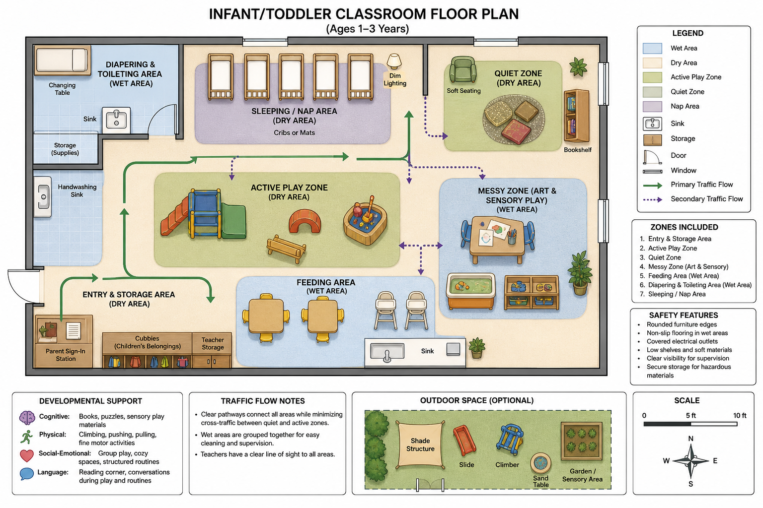

References
Kaplan Early Learning Company. (n.d.). Infant and toddler classroom environments.
Community Playthings. (n.d.). Infant and toddler spaces.
Head Start Early Learning Outcomes Framework. (n.d.). Early learning environments.

