PART 1: THE GATECRASHER DOSSIER

SECTION 1A — VIRAL THREAT PROFILE: Structure & Hijacking
A virus is an infectious non-cellular particle: genetic material (DNA or RNA) encased in a protein shell (capsid) and sometimes surrounded by a lipid envelope with surface proteins. Viruses are classified as non-living because they can't replicate by themselves; instead, they use five steps to infect their hosts:

- Attachment: Viral surface proteins attach to host cell receptors.
- Penetration: The virus introduces its nucleic acid into the cell, which releases its genetic instructions.
- Synthesis: The virus takes over host ribosomes to mass-produce new viral nucleic acids and proteins.
- Assembly: The new viral components will assemble into thousands of new virus particles on their own.
- Release: New viruses break out (lysis) or detach and are available to infect another cell.

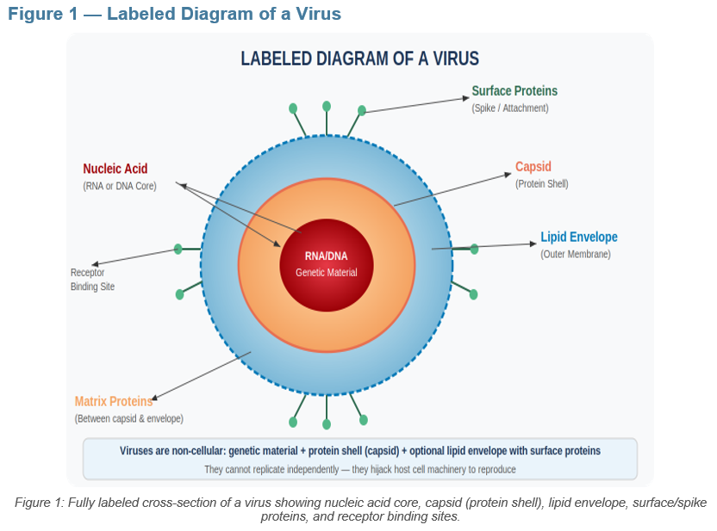

Pathogen Comparison Table
Type | Example | Notes
Virus | Influenza (H1N1) | Airborne — rapid pandemic spread
Virus | HIV | Destroys immune T-cells (AIDS)
Bacteria | Streptococcus | Strep throat; antibiotic-treatable
Bacteria | Treponema pallidum | Syphilis; sexually transmitted
Parasite | Plasmodium | Malaria via mosquito vector
Parasite | Tinea (fungus) | Athlete's foot; skin infection

SECTION 1B — KREWE SECURITY MAP: Innate Defenses as Festival Security
Innate immunity is the non-specific, unconditionally active initial line of attack of the body - it is present at birth, and it does not need any prior exposure to a pathogen. Consider it festival security prior to gatecrashers getting to the main stage:

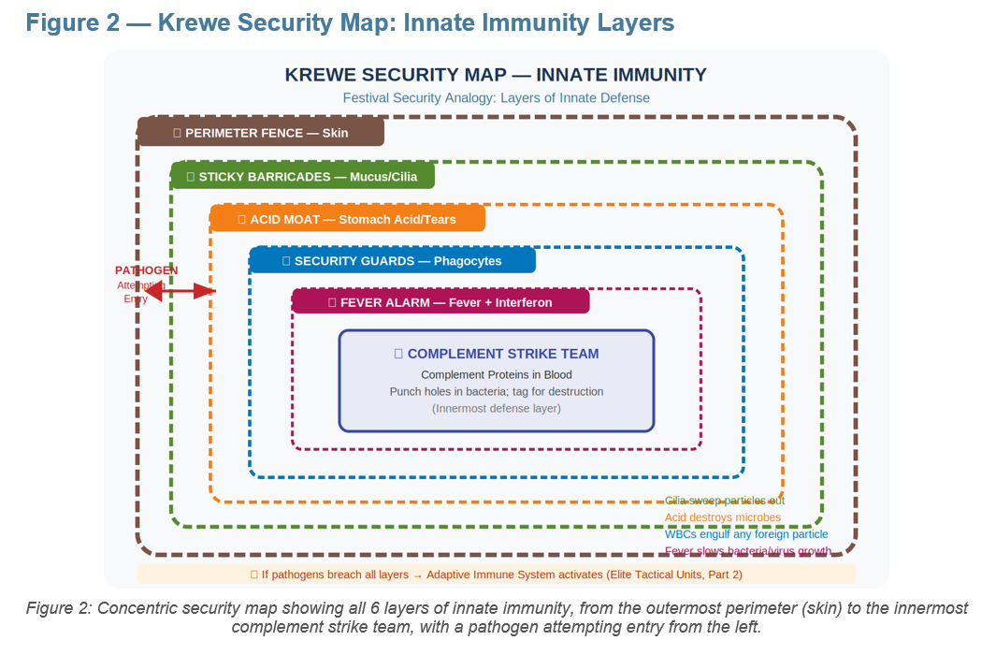

Krewe Security Map — Innate Immunity: Primary Line of Defense
Security Layer | Biological Component | Function
Perimeter Fence | Skin (tightly packed cells) | Physical barrier — pathogens cannot penetrate intact skin
Sticky Barricades | Mucus + Cilia | Trap particles; cilia sweep them away before entry
Acid Moat | Stomach acid / Tears / Saliva | Chemical destruction — kills most ingested microbes
General Security Guards | Phagocytes (white blood cells) | Engulf and digest any foreign particle — no ID check needed
Fever Alarm System | Fever + Interferon proteins | Fever inhibits bacterial growth; interferon slows viral replication
Complement Strike Team | Complement proteins in blood | Punch holes in bacterial walls; tag pathogens for destruction

DOSSIER NOTE: Even with these layers, some pathogens breach the perimeter. That triggers the Adaptive Immune System (Elite Tactical Units — see Bouncer Training Manual, Part 2).

