Generations & Defenses: A Family & Community Biology Quilt

Name of Author
Institutional Affiliation
Course Code and Number
Instructor Name
Date of Submission

Generations & Defenses: A Family & Community Biology Quilt
Cultivating Continuity: Plant Reproduction
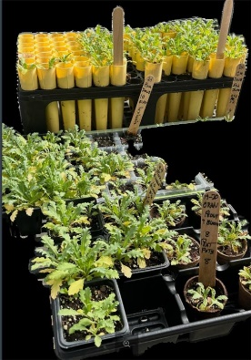
Southern University Agriculture Center represents Biological propagation through cultivating seedlings, which is the basic mechanism of survival of the species and continuity of genetic information. This will be culturally equivalent to generational development at Southern University, Baton Rouge (SUBR), thus ensuring a consistent local food supply is maintained, and the transfer of strong plant genetics towards future generations to maintain agricultural populations is achieved.
Fueling the Defense: Nutritional Immunity
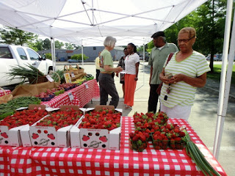
The Baton Rouge farmers' market demonstrates the crucial crossroads of community resources and biological immune health. The human immune system is highly dependent on regular uptake of micronutrients to work best. Local, fresh products are rich in vitamins and antioxidants that regulate the activity of leukocytes and prevent the host cells in extreme oxidative stress, thus playing an active role in supporting the innate defenses of the organism (Doaei et al., 2023). The market enables the provision of these essential nutrients, thereby providing macro-level community defense mechanisms to aid in the prevention of microscopic diseases.
Fostering Life: Animal Husbandry and Reproductive Science
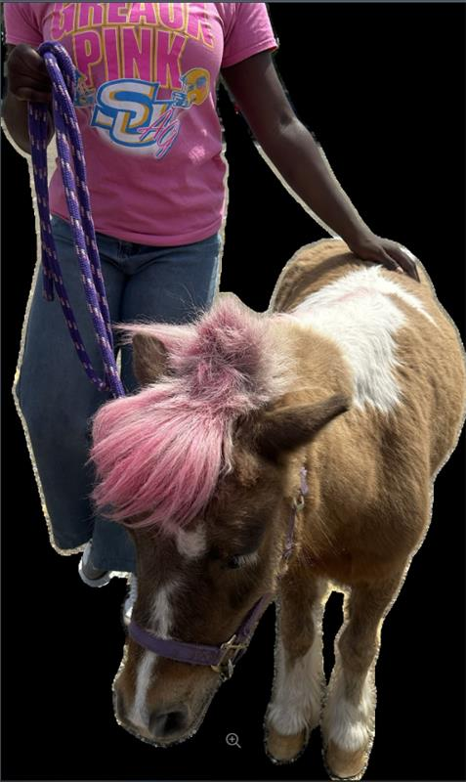
The pony and SU Ag student are a representation of applied reproductive science and biological continuity. This will be a selective breeding that guarantees the transfer of viable genetics across the generations, which is the promise of SUBR to maintain the traditions of agriculture and the basic biological need of species survival.
Agricultural Adaptation: SU's Vineyards
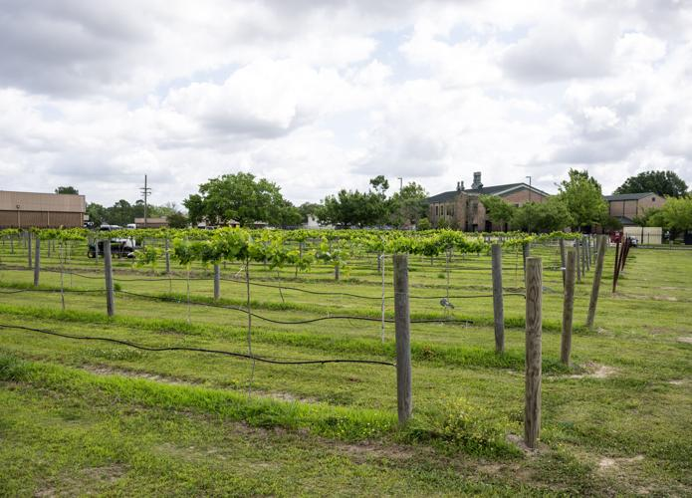
The SU vineyards relate these biological concepts to campus life. Grapevines need a lot of agricultural adaptation and physiological strength to grow in Baton Rouge with its hot climate. Grapevines need to use sophisticated biological defense systems and physiological adaptations to endure environmental stress and climate change (Konecny et al., 2025). In addition, it is essential to use specific farming interventions to mitigate excessive thermal stress to maintain such robust plant lineages (Pallotti et al., 2026). This discriminatory breeding is an ideal combination of biological science in action and community innovation.
Synthesis & Connection
This quilt square can be linked to my portfolio because it demonstrates how biology at the individual and cultural sphere can be related to systems and adaptations we have previously learned. Building upon the earlier units on cell structure and genetics, this entry shows how microscopic continuity is increased to physical reproduction in the SU Ag Center and how communities engage in constructing a strong immune response, exemplifying how our HBCU evolves and flourishes.

References
Doaei, S., Mardi, A., & Zare, M. (2023). Role of micronutrients in the modulation of immune system and platelet activating factor in patients with COVID-19; a narrative review. Frontiers in Nutrition, 10, 1207237.doi: 10.3389/fnut.2023.1207237
Konecny, T., Asatryan, A., & Binder, H. (2025). Responding to Stress: Diversity and Resilience of Grapevine in a Changing Climate Under the Perspective of Omics Research. International Journal of Molecular Sciences, 26(16), 7877. https://doi.org/10.3390/ijms26167877
Pallotti, L., Lattanzi, T., Lanari, V., & Silvestroni, O. (2026). Assessment of the Heat-Stress-Mitigating Effect of Kaolin in Grapevine: A Comparative Study in Two Vineyards. Horticulturae, 12(3), 325. https://doi.org/10.3390/horticulturae12030325

