User Experience Report

Name of Author
Instructor Name
Institutional Affiliation
Course Code and Number
Date of Submission

User Experience Report

Introduction
Lubbock Sports is a web-based tourism and event-planning portal that is created to assist sports planners and sports fans in locating amenities, venues, and travel choices pertinent to the town of Lubbock, Texas. In general, the participants experienced enormous navigation problems and could not easily find essential details, hidden inside downloadable PDFs, nor could they find efficient tools to check the availability of the facilities or reserve facilities. The mean of the overall rating of six respondents, regarding the websites, consisted of 2.67 out of 5, which might be considered a rather disappointing experience despite the visually attractive impression of the given site.

Purpose
This usability test was aimed at determining the usability in finding information that was pertinent to the process of planning a sports-based event in Lubbock, Texas, with the help of the Lubbock Sports site. The main research question informing the assessment was the following: How well can users quickly and accurately locate information related to planning a sports-based event in Lubbock, TX? The test particularly evaluated efficiency, frequency of errors, and satisfaction of the user in three real-life situations of facility rents, venue search, and transport planning.
Methodology
The usability test was administered to six participants. All participants met the eligibility criteria. The age span of the participant group was 25 to 65 years, with the bracket of age 35-44 years having the majority. Dental student, stay-at-home parent, software architect, technical writer, librarian, and lawyer. The testing was done using video conferencing and screen sharing, where a moderator would take participants through some tasks as they thought aloud. Those who participated went through a pretest survey, three sets of tasks administered as a scenario, completed post-task ratings, and a post-task debrief interview, which included Product Reaction Card choices. Measurement scales comprised of time on task (in minutes and seconds taken to complete the task, start to finish), task completion success rate (how many attempts the task was completed successful out of six participants), post-task ratings of actual difficulty (scale of 1-5, easy-hard), a general rating on site quality (scale of 1-5, very poor-very good), and qualitative feedback (think aloud comments, observations of the facility.

Results
The completion of tasks across the three scenarios had great variation. In Scenario 1, tasks 1 and 3 were very successful (100% completion) while Task 4 was unsuccessful, with the majority of participants either not able to locate availability information. Scenario 2 indicated the overall success with 83% of participants completing the assigned task; however, Task 2 took the longest for participants to complete, and one participant did not complete any task in Scenario 2. Overall, Scenario 3 performed the worst with the driving-distance task, with only having 50% of participants completing this task. Participants rated the difficulty level to be moderate (3.0 – 3.3/5 across all scenarios). Participants indicated that the website used poor search capabilities and had confusing layouts. Based on the reaction cards completed by the participants, they had an overall negative usability impression of the website, indicating "Frustrating", "Confusing", and "Unclear". Nonetheless, the layout and presentation of the website were well received, being described as "Professional" and "Informative".
Task Completion Success Rate
The task completion success rate represents the number of successful completions divided by the total number of participants (6).

Scenario One
Participant | Task 1 | Task 2 | Task 3 | Task 4 | Task 5 | Task 6
1 | Yes | Yes | Yes | No (never located) | Yes | Yes
2 | Yes | Yes | Yes | Yes | Yes | Yes
3 | Yes | Yes | Yes | Yes | Yes | Yes
4 | Yes | Yes | Yes | No (never located) | Yes | Yes
5 | No | No | Yes | Yes | No | No
6 | Yes | Yes | Yes | Yes | Yes | Yes
Success | 5 | 5 | 6 | 4 | 5 | 5
Completion Rate | 83% | 83% | 100% | 67% | 83% | 83%

Scenario Two
Participant | Task 1 | Task 2 | Task 3 | Task 4 | Task 5 | Task 6
1 | Yes | Yes | Yes | Yes | Yes | Yes
2 | Yes | Yes | Yes | Yes | Yes | Yes
3 | Yes | No | No | No | No | Yes
4 | Yes | Yes | Yes | Yes | Yes | Yes
5 | Yes | Yes | Yes | Yes | Yes | Yes
6 | Yes | Yes | Yes | Yes | Yes | Yes
Success | 6 | 5 | 5 | 5 | 5 | 6
Completion Rate | 100% | 83% | 83% | 83% | 83% | 100%

Scenario Three
Participant | Task 1 | Task 2 | Task 3 | Task 4 | Task 5 | Task 6
1 | Yes | No | No | No | Yes | Yes
2 | Yes | No | Yes | No | Yes | Yes
3 | Yes | No | Yes | Yes | Yes | Yes
4 | Yes | Yes | Yes | No | Yes | Yes
5 | Yes | Yes | Yes | Yes | Yes | Yes
6 | Yes | Yes | Yes | Yes | Yes | Yes
Success | 6 | 3 | 5 | 4 | 6 | 6
Completion Rate | 100% | 50% | 83% | 67% | 100% | 100%

Average Time on Task

Times are recorded in minutes and seconds (MM: SS). Times marked 'never located' indicate the participant was unable to complete that task.

Scenario One
Participant | Task 1 | Task 2 | Task 3 | Task 4 | Task 5 | Task 6
1 | 0:42 | 1:13 | 0:20 | 4:01 | 0:22 | 0:09
2 | 0:06 | 0:14 | 2:14 | 1:19 | 0:05 | 0:01
3 | 1:31 | 0:30 | 0:49 | 0:02 | 0:11 | 0:02
4 | 0:05 | 0:34 | 1:37 | 2:14 | 0:07 | 0:01
5 | 1:01 | 1:10 | 0:36 | 1:08 | 1:28 | 1:48
6 | 1:12 | 0:24 | 0:15 | 0:49 | 0:04 | 0:03
Average | 0:46 | 0:40 | 0:58 | 1:35 | 0:22 | 0:20

Scenario Two
Participant | Task 1 | Task 2 | Task 3 | Task 4 | Task 5 | Task 6
1 | 0:02 | 1:44 | 2:14 | 1:07 | 1:04 | 0:02
2 | 0:05 | 1:35 | 0:09 | 2:37 | 1:08 | 0:01
3 | 0:02 | 3:31 | 2:13 | 2:53 | 4:01 | 0:02
4 | 0:04 | 3:24 | 0:14 | 1:34 | 0:35 | 0:13
5 | 0:05 | 1:12 | 1:38 | 0:36 | 0:07 | 0:05
6 | 0:03 | 1:02 | 0:18 | 0:23 | 0:05 | 0:02
Average | 0:03 | 2:04 | 1:07 | 1:31 | 1:10 | 0:04

Scenario Three
Participant | Task 1 | Task 2 | Task 3 | Task 4 | Task 5 | Task 6
1 | 0:04 | 2:34 | 1:59 | 2:51 | 1:01 | 0:02
2 | 0:02 | 4:34 | 0:06 | 1:43 | 0:14 | 0:01
3 | 0:03 | 3:01 | 2:20 | 2:24 | 2:30 | 0:01
4 | 0:01 | 2:35 | 0:25 | 3:22 | 0:16 | 0:01
5 | 0:05 | 1:18 | 0:03 | 0:15 | 0:34 | 0:03
6 | 0:01 | 1:32 | 0:08 | 0:45 | 0:04 | 0:22
Average | 0:02 | 2:35 | 0:50 | 1:53 | 0:46 | 0:05

Website Ratings

Participants rated the overall quality of the website on a scale from 1 (very poor) to 5 (very good) during the debrief interview.

Participant | Overall Website Rating
1 | 2
2 | 1
3 | 3
4 | 2
5 | 4
6 | 4
Average Rating | 2.67

Summary of Data

This section highlights key findings across all three scenarios, connecting task completion rates and average completion times to support the recommendations below.

Scenario One
Task | Task Completion Rate | Average Task Completion Time
1 | 100% | 0:46
2 | 83% | 0:40
3 | 100% | 0:58
4 | 67% | 1:35
5 | 83% | 0:22
6 | 83% | 0:20

Scenario Two
Task | Task Completion Rate | Average Task Completion Time
1 | 100% | 0:03
2 | 83% | 2:04
3 | 83% | 1:07
4 | 83% | 1:31
5 | 83% | 1:10
6 | 100% | 0:04

Scenario Three
Task | Task Completion Rate | Average Task Completion Time
1 | 100% | 0:02
2 | 50% | 2:35
3 | 83% | 0:50
4 | 67% | 1:53
5 | 100% | 0:46
6 | 100% | 0:05

Discussion

All scenarios had common issues finding the Sports subpage from the Visit Lubbock homepage, since many users would scroll to the bottom rather than using the dropdown, demonstrating difficulty with the information architecture and hierarchy of content. Additionally, the location of important information was hidden in a poorly labeled PDF that was accessed via "Learn More," causing users to experience challenges locating the information and being successful; the users also noted that broken links and formatting issues added to the difficulty. Some users even had to exit the website to find what they were looking for. Additionally, the lack of an online system to check availability or make reservations required users to use contact forms as the primary method of making a reservation.
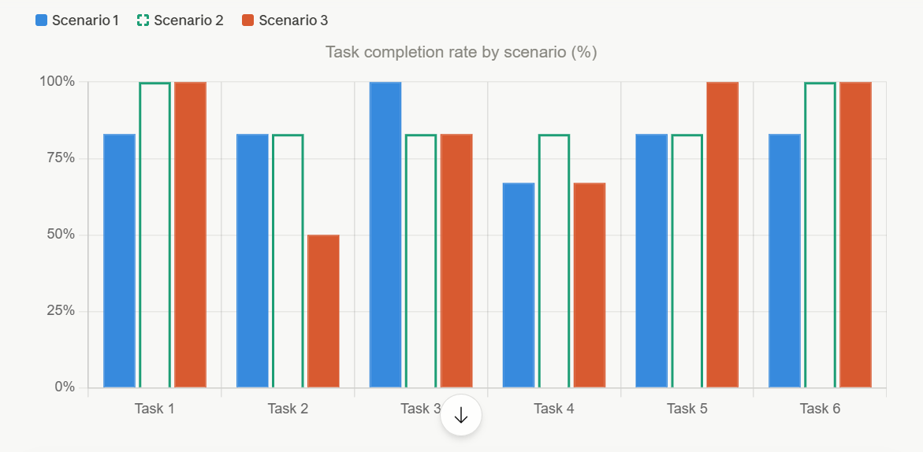

Figure 1: Task Completion rate by scenario

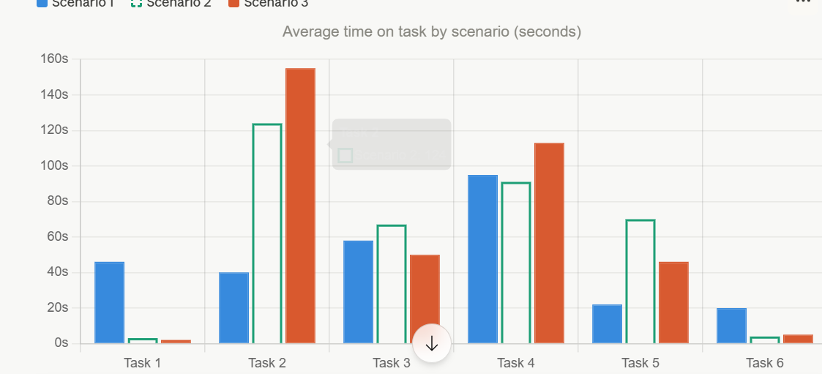

Figure 2: Average time on task by scenario
The rates of task completion in all three situations are shown in Figure 1. In general, Scenario 2 was the most stable one, and Tasks 1 and 6 demonstrated 100 percent completion. Nevertheless, deviant areas of problems were observed in different situations. In Scenario 3, the lowest completion rate amongst all the studies was recorded in Task 2, with only 50% completing the entire study. Task 4 indicated a pattern of low completion rates of 67% in both Scenario 1 and Scenario 3, indicating a consistency in a failure point concerning facility availability information. These trends affirm that navigation and accessibility of information are the greatest weaknesses of the site in terms of its usability. Fig 2 provides the average duration that the participants took to accomplish the various tasks in each of the three scenarios in seconds. Tasks 1 and 6 were perfunctorily accomplished in every scenario, indicating that it was easy and well-supported by the site. However, Task 2 in Scenario 2 and Scenario 3 took the longest time, with an average of 124 and 155 seconds, respectively, indicating a high level of difficulty faced by users. The average of 113 seconds of Task 4 in Scenario 3 and 67% of it being undone, validates it as being one of the most problematic tasks. These long durations are directly related to an ineffective navigation structure, combined with highly contented buried material all over the site.

Recommendations
The priority of the recommendation is the redesign of the site navigation. The existing drop-down menu cannot be visually scrolled, and significant links cannot be found, which makes it difficult for users to navigate certain information. Studies have revealed that the kind of navigation menu has a great impact on user experience and that the menus ought to be designed in a way that provides accessible, efficient, usable, and effective navigation (Umar et al., 2024). A well-defined top-tier navigation site will cut down the time and frustration that users face once they have to take the first step towards any activity and improve site efficiency.
The second guideline is not to keep facility and venue details in a PDF document, but via specific web pages classified by sport or venue. A study comparing PDF accessibility to that of alternative textual formats discovered that most PDF documents lack alternative text equivalents to the images and that only a minor percentage of documents are created as correctly tagged documents, thus posing a considerable challenge to users who require assistive technologies to access information on the web (Kumar & Wang, 2024). The PDF itself has broken links, inconsistent formatting, and typos. Plugging content directly on the site with a standardized structure across the venues would overall increase the average quality rating of the site.
The third suggestion is to incorporate an availability calendar and a well-marked transportation page. A study on the reservation systems on sports facilities over the internet discovered that the old manual system of reservation is lengthy, expensive, and unproductive, and that web-based applications that enable users to find facilities and view real-time availability enhanced the user experience (Arief Ichwani et al., 2025). The half-completion rate in Scenario Three Task 2 and the 67 percent rate in Scenario One Task 4 show that the site is unable to deliver two types of information users actively require: the means of accessibility and availability of the facilities. A live reservation system of sports facilities and a convenient, easy-to-access transport page, with the driving radius, highway data, and the transportation facilities in the area well-marked and displayed, would improve the efficiency.

Conclusion
Usability testing conducted on the Lubbock Sports website revealed that users found the site visually appealing but had difficulty performing tasks related to scheduling and planning. Specific concerns included difficult navigation, a reliance on a hard-to-find PDF document for information, and no apparent method to make reservations. Overall, users reported being frustrated with the website and rated it poorly (2.67 on a 5-point scale). Many participants reported frustration because they could not find information on the website (versus it not being present). To improve user experience and effectiveness of the website, navigation should be improved, content should be more readily visible on the web page, and scheduling/planning tools should be added.
References
Arief Ichwani, Idris, M., & Aidil Afriansyah. (2025). Web-based application development for the digitalization of badminton court reservation and scheduling using Scrum methodology. Journal of Intelligent Decision Support System (IDSS), 8(No. 3), 144–153. https://doi.org/10.35335/idss.v8i3.310
Kumar, A., & Wang, L. L. (2024). Uncovering the New Accessibility Crisis in Scholarly PDFs: Publishing Model and Platform Changes Contribute to Declining Scholarly Document Accessibility in the Last Decade. The 26th International ACM SIGACCESS Conference on Computers and Accessibility, 1–16. https://doi.org/10.1145/3663548.3675634
Umar, M., Hussain, I., Mahmood, T., Mirza, H. T., & Nadeem, M. (2024). Design Strategies to Minimize Mobile Usability Issues in Navigation Design Patterns. Information, 15(11), 732–732. https://doi.org/10.3390/info15110732

